|  | **CAN THO UNIVERSITY SOFTWARE CENTER** |  |
| --- | --- | --- |
| **MEKONG DELTA - APTECH** |

**Aptech Certified Computer Professional (ACCP)**

**SEMESTER II**

**FURNITURE SYSTEM**

| **Instructor:** | **Class: CP2296H07** |
| --- | --- |
| MSc. Le Thi Minh Loan | **Team:** |
| **Students:**  1.A22078-Pham Bao Quoc  2. A22082-Nguyen Ngoc Bao Thi  3.A22087-Nguyen Minh Tri Duc  4.A22092-Nguyen Duong Kieu Diem Quynh |

Can Tho, 06/2023

**PROBLEM DEFINITION OF PROJECT**

Today, businesses, including Fair Deal furniture stores are facing difficulties in managing information and products due to increasing demand. Fair Deal sells a wide range of furniture for homes, offices and hospitals. With a large number of employees, the management of products, orders, and prices are handled manually by employees. The store doesn't have a management system yet, so everything is handled manually. To address these challenges, our team has developed a management software called Furniture Systems Software for Fair Deal.

The software serves as an online sales management system for the store, allowing customers to purchase goods by downloading the application. Customers can create an account, search for products, and place orders through the system. The software simplifies management tasks by providing information on available products, prices, orders, and staff. It also facilitates revenue calculation, profit and loss analysis, and proposes solutions such as price adjustments.

The main business processes include: Profile management: making it easier to manage information, accounts of customers and employees. Make accessing, editing and looking up convenient, saving time; Catalog management: each product will be in a certain category, customers can search for products through the catalog to help customers easily find products; Product management: Customers will search for products on the search bar, the system will take customers to products that match their needs. In addition, customers can search for products through the product catalog. Each product has a detailed description, price, quantity. Help customers grasp product information quickly; Product promotion: staff will be the creator and manager of promotional codes, promo codes will apply to all products. Order management: customers add products to the cart, the system goes to the payment page, customers choose a payment method, fill in customer information,... after the customer places an order, the system will fully record it information and transfer it to the order management department, the staff will manage the order, prepare the order and transfer the product to the warehouse for shipping. In this operation, the system will help customers pay simply and quickly and help staff manage orders easily. After paying for the order, the system will issue an invoice and the staff will manage the customer's order; Warehouse management: products in stock include managing the quantity of goods in stock, quantity, suppliers, etc. to help manage products in the warehouse clearly, easily linked with products for sale; Importing products into the warehouse: Staff will manage imported products, manage quantity, quality, suppliers, etc., thereby capturing full product information to help manage products in the warehouse easier; Customer debt management: this is the part that manages the amounts that customers pay for bills, the store allows customers to pay 50% or more, the system will list accounts, customer information, order. Makes revenue calculations clearer and easier; Supplier: this is the place to supply products to the warehouse, manage suppliers including name, address, quantity, quality, etc. Product feedback management: After purchasing and receiving goods, customers will be evaluated on the quality of products and services. Customer reviews will be included in the feedback management section. Staff will see customer reviews to fix and support customers.

Overall, the Furniture System Software streamlines operations, saves time, and enhances the customer experience for Fair Deal furniture store.

**CUSTOMER REQUIREMENTS SPECIFICATION (CRS)**

**Name of Project**: Furniture System

1. **Modeling requirements of customer (Use case Diagram)**

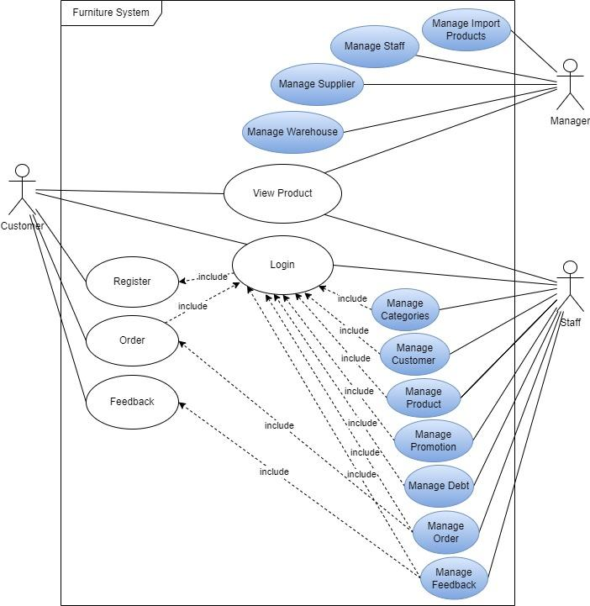

1. **Actor Description**

| **No.** | **Actor** | **Use Case** | **Description** |
| --- | --- | --- | --- |
|  | Manager | Manage Import Products | This module allows the Manager to manage the import of products such as viewing, adding, editing, deleting and searching the list of import products, import time, quantity, supplier name. |
| Manage Staff | This module allows the Manager to manage information of staff including viewing the list of staff, adding new staff, updating staff information, deleting staffs and searching for staff. |
| Manage Supplier | This module allows the Manager to manage supplier’s information including viewing the list of suppliers, adding new suppliers, updating supplier information, deleting suppliers and searching for suppliers. |
| Manage Warehouse | This module allows the Manager to manage the warehouse such as viewing the warehouse list, adding, editing, deleting the warehouse. |
| View Product | This module allows the Manager to see all the products displayed on the screen of the application. |
|  | Staff | Manage Categories | This module allows employees to view, edit, and delete categories |
| Manage Customer | This module allows the Staff to manage information of customers including viewing the list of customers, adding new customers, updating customer information, deleting customers and searching for customers. |
| Manage Product | This module allows the Staff to manage information about products including viewing the list of products, adding new products, updating product information, deleting products and searching for products. |
| Manage Promotion | This module allows the Staff to add, edit, and delete promotions, promotional time and content. |
| Manage Debt | This module allows the Staff to manage debts of installment customers, help employees view, add, edit and delete the list of outstanding customers and check the remaining debt, monthly payment term. |
| Manage Feedback | This module allows employees to view the list of feedback, feedback time and status updates (processed or unprocessed) of customer feedback for products purchased by customers. |
| Manage Order | This module allows the Staff to manage information of order including viewing the list of orders, adding new orders, updating order information, deleting orders and searching for orders. |
| Login | This module allows the Staff to login to the Staff app using a premade account. |
| View Product | This module allows the Staff to see all the products displayed on the screen of the application. |
| 3. | Customer | View Product | This module allows the Customer to see all the products displayed on the screen of the application. |
| Register | This module allows the Customer to register an account to login to the client application. |
| Login | This module allows the Customer to login to the client application with a registered account. |
| Order | This module allows the Customer to place orders after selecting the desired product from the client application. |
| Feedback | This module allows the Customer to give feedback on the product that the customer has purchased, the customer's review of the product, or when the product has an error during shipping or a supplier error. |

1. **Use case Description**
   1. **Manage Import Products:** This module allows the Manager to manage the import of products such as **viewing, adding, editing, deleting and searching the list of import products, import time, quantity, supplier name.**

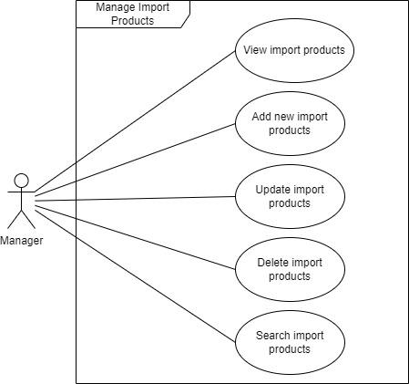

* + 1. **View import products**
* Purpose: this function allows the Manager to view information of import products.
* Inputs: Click **Manage Import Product** button.
* Outputs: information of import products in the **Import_Product** and **Import_Product_Detail** table will be displayed on the screen.
  + 1. **Add new import products**
* Purpose: this function allows the Manager to add new import products to the database
* Inputs:
  + Import ID
  + Import product name
  + Quantity
  + Supplier ID
  + Warehouse ID
  + Import day
* Outputs: new import products will be added to the **Import_Product** and **Import_Product_Detail** table in the database.
  + 1. **Update import products**
* Purpose: this function allows the Manager to update the information of import products.
* Inputs:
* new Import ID
* new Import product name
* new Quantity
* new Supplier ID
* new Warehouse ID
* new Import day
* Output: new information will be updated in the **Import_Product** and **Import_Product_Detail** table.
  + 1. **Delete import products**
* Purpose: this function allows the Manager to delete import products in the **Import_Product** and **Import_Product_Detail** table.
* Inputs:
  + Import ID
* Outputs: import products will be deleted in the **Import_Product** and **Import_Product_Detal** table.
  + 1. **Search import products**
* Purpose: this function allows the Manager to search for import products in the **Import_Product** and **Import_Product_Detal** table.
* Inputs:
  + Search input value.
* Outputs: the corresponding list of import products in the **Import_Product** and **Import_Product_Detal** table will be displayed on the screen.
  1. **Manage Staff:** This module allows the Manager to manage information of staff including **viewing the list of staffs, adding new staffs, updating staff information, deleting staffs and searching for staffs.**

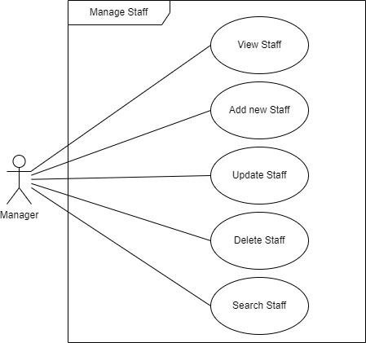

* + 1. **View Staff**
* Purpose: this function allows the Manager to view information of staff.
* Inputs:
* Click the **Manage Staff** button.
* Outputs: information of staff in the **Staff** table will be displayed on the screen.
  + 1. **Add new Staff**
* Purpose: this function allows the Manager to add new staff to the database.
* Inputs:
* Staff name
* Address
* Phone
* Email
* Salary
* Username
* Password
* Outputs: new staff will be added to the **Staff** table in the database.
  + 1. **Update Staff**
* Purpose: this function allows the Manager to edit the Staff’s information.
* Inputs:
* new Staff name
* new Address
* new Phone
* new Email
* new Salary
* new Username
* new Password
* Outputs: new staff information will be updated in the **Staff** table.
  + 1. **Delete Staff**
* Purpose: this function allows the Manager to delete the staff in the **Staff** table.
* Inputs:
* Staff ID
* Outputs: staff will be deleted in the **Staff** table.
  + 1. **Search Staff**
* Purpose: this function allows the Manager to search for the staff in the **Staff** table.
* Inputs:
* Search input value
* Outputs: the corresponding list of staffs in the **Staff** table will be displayed on the screen.
  1. **Manage Supplier:** this module allows the Manager to manage supplier’s information including **viewing the list of suppliers, adding new suppliers, updating supplier information, deleting suppliers and searching for suppliers**

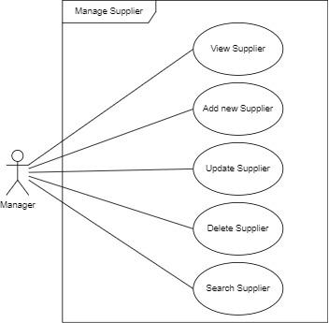

* + 1. **.View Supplier**
* Purpose: this function allows the Manager to view information about the supplier.
* Inputs:
* Click the **Manage Supplier** button.
* Outputs: Information of suppliers in the **Supplier** table will be displayed on the screen.
  + 1. **.Add new Supplier**
* Purpose: this function allows the Manager to add a new supplier to the database.
* Inputs:
* Supplier ID
* Supplier name
* Address
* Phone
* Outputs: new supplier will be added to the **Supplier** table in the database.
  + 1. **.Update Supplier**
* Purpose: this function allows the Manager to edit the Supplier’s information.
* Inputs:
* new Supplier ID
* new Supplier name
* new Address
* new Phone
* Outputs: new supplier information will be updated in the **Supplier** table.
  + 1. **.Delete Supplier**
* Purpose: this function allows the Manager to delete the supplier in the **Supplier** table.
* Inputs:
* Supplier ID
* Outputs: supplier will be deleted in the **Supplier** table.
  + 1. **.Search Supplier**
* Purpose: this function allows the Manager to search for the supplier in the **Supplier** table.
* Inputs:
* Search input value
* Outputs: the corresponding list of suppliers in the **Supplier** table will be displayed on the screen.
  1. **Manage Warehouse:** This module allows the Manager to manage the warehouse such as **viewing the warehouse list, adding, editing, deleting the warehouse.**

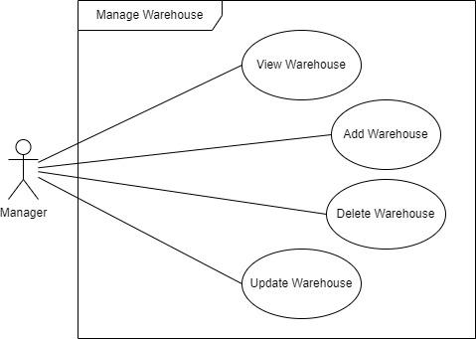

* + 1. **Add Warehouse**
* Purpose: this function allows the Manager to add a new warehouse to the **Warehouse** table.
* Inputs:
* Warehouse ID
* Warehouse name
* Address
* Outputs: new warehouses will be added to the **Warehouse** table in the database.
  + 1. **Update Warehouse**
* Purpose: this function allows the Manager to update the information of the warehouse.
* Inputs:
* new Warehouse name
* new Address
* Outputs: new information will be updated in the **Warehouse** table.
  + 1. **Delete Warehouse**
* Purpose: this function allows the Manager to delete the warehouse in the  **Warehouse** table.
* Inputs:
* Warehouse ID
* Outputs: warehouse will be deleted in the **Warehouse** table.
  + 1. **View Warehouse**
* Purpose: this function allow Manager to see the number of warehouses.
* Inputs:
* Click the **Manage Warehouse** button.
* Outputs: the number of warehouses will be displayed on the screen.
  1. **View Product**
* Purpose: this function allows the Manager, Staff and Customer to see all the products in the application.
* Inputs:
* Click the Product button.
* Outputs: all products will be displayed on the screen.
  1. **Manage Categories:** this module allows employees to view, edit, and delete categories
     1. **View Categories**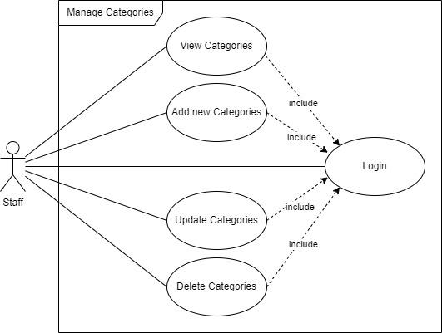
* Purpose: this function allows Staffs to view the list of categories in the **Category** table
* Inputs:
  + Click the **Manage Category** button.
* Outputs: the list of categories in the **Category** table will be displayed on the screen.
  + 1. **Add new Categories**
* Purpose: this function allows Staffs to add new Categories to the **Category** table.
* Inputs:
  + Category ID
  + Category name
* Outputs: new categories will be added to the **Category** table in the database.
  + 1. **Update Categories**
* Purpose: this function allows the staff to edit the Category’s information.
* Inputs:
* new Category ID
* new Category name
* Outputs: new information will be updated in the **Category** table.
  + 1. **Delete Categories**
* Purpose: this function allows the staff to delete the category in the **Category** table.
* Inputs:
  + Category ID
* Outputs: the corresponding category will be deleted in the **Category** table.
  1. **Manage Customer:** this module allows the Staff to manage information of customers including **viewing the list of customers, adding new customers, updating customer information, deleting customers and searching for customers.**

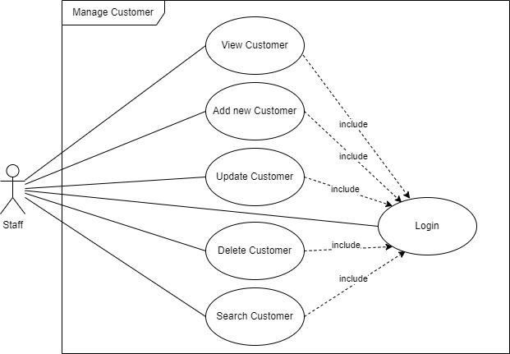

* + 1. **View Customer**
* Purpose: this function allows Staffs to view information of customers.
* Inputs:
* Click the **Manage Customer** button.
* Outputs: information of customers in the **Customer** table will be displayed on the screen.
  + 1. **Add new Customer**
* Purpose: this function allows Staff to add new customers to the **Customer** table.
* Inputs:
* Customer name
* Address
* Phone
* Email
* Username
* Password
* Outputs: new customers will be added to the **Customer** table in the database.
  + 1. **Update Customer**
* Purpose: this function allows the staff to edit the Customer’s information.
* Inputs:
* new Customer name
* new Address
* new Phone
* new Email
* new Username
* new Password
* Outputs: new customer information will be updated in the **Customer** table.
  + 1. **Delete Customer**
* Purpose: this function allows the staff to delete the customer in the **Customer** table.
* Inputs:
* Customer Name
* Outputs: customer will be deleted in the **Customer** table.
  + 1. **Search Customer**
* Purpose: this function allows the staff to search for the customer in the **Customer** table.
* Inputs:
* Search input value
* Outputs: the corresponding list of customers in the **Customer** table will be displayed on the screen.
  1. **Manage Product:** This module allows the Staff to manage information about products including **viewing the list of products, adding new products, updating product information, deleting products and searching for products.**

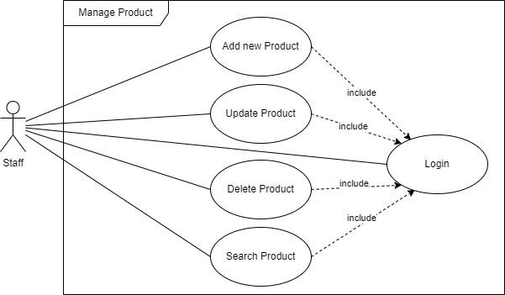

* + 1. **Add new Product**
* Purpose: this function allows Staffs to add new Product to the **Product** table.
* Inputs:
* Product ID
* Product name
* Price
* Quantity left in stock
* Color
* Size
* Image
* Description
* Category ID
* Outputs: new product will be added to the **Product** table and it will be displayed on the screen in the client application.
  + 1. **Update Product**
* Purpose: this function allows the staff to edit the Product’s information.
* Inputs: new value
* Outputs: new information will be updated in the **Product** table.
  + 1. **Delete Product**
* Purpose: this function allows the staff to delete products in the **Product** table.
* Inputs:
* Product ID
* Outputs: product will be deleted in the **Product** table.
  + 1. **Search Product**
* Purpose: this function allows the staff to search for products in the **Product** table.
* Inputs:
* Product name
* Price
* Outputs: the corresponding list of products in the **Product** table will be displayed on the screen.
  1. **Manage Promotion:** this module allows the Staff to **add, edit, and delete promotions, promotional time and content.**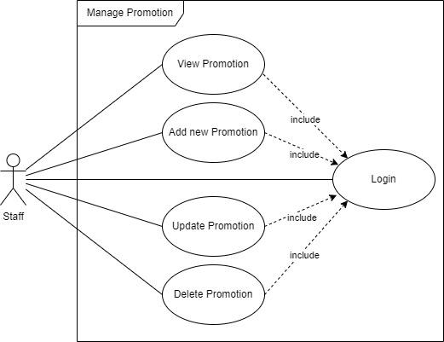
     1. **View Promotion**
* Purpose: this function allows the Staff to view information of promotion.
* Inputs: Click **Manage Promotion** button.
* Outputs: information of promotion in the **Promotion** table will be displayed on the screen.
  + 1. **Add new Promotion**
* Purpose: this function allows Staffs to add new promotions to the **Promotion** table.
* Inputs:
  + Promotion ID
  + Promotion name
  + Promotion type
  + Start day
  + End day
  + Status
* Outputs: new promotion will be added to the **Promotion** table.
  + 1. **Update Promotion**
* Purpose: this function allows Staffs to edit the Promotion’s information.
* Inputs:
* new Promotion name
* new Promotion type
* new Start day
* new End day
* new Status
* Outputs: new information will be updated in the **Promotion** table.
  + 1. **Delete Promotion**
* Purpose: this function allows Staffs to delete promotions in the **Promotion** table.
* Inputs:
  + Promotion ID
* Outputs: promotion will be deleted in the **Promotion** table.
  1. **Manage Debt:** this module allows the Staff to **manage debts of installment customers, help employees view, add, edit and delete the list of outstanding customers and check the remaining debt, monthly payment term.**

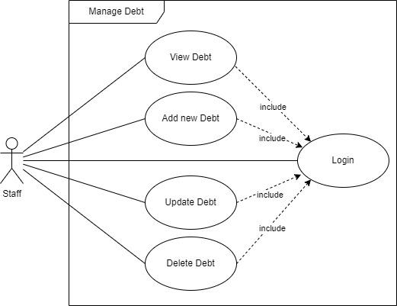

* + 1. **View Debt**
* Purpose: this function allows the Staff to view information of debt.
* Inputs: click **Manage Debt** button.
* Outputs: information of debt in the **Debt** table will be displayed on the screen.
  + 1. **Add new Debt**
* Purpose: this function allows Staffs to add new debt to the **Debt** table.
* Inputs:
  + Debt ID
  + Customer ID
  + Customer name
  + Debt day
  + Pay date
  + Amount owed
* Outputs: new debt will be added to the **Debt** table.
  + 1. **Update Debt**
* Purpose: this function allows Staffs to edit the debt’s information.
* Inputs:
* new Debt day
* new Pay date
* new Amount owed
* Outputs: new information will be updated in the **Debt** table.
  + 1. **Delete Debt**
* Purpose: this function allows Staffs to delete debt in the **Debt** table.
* Inputs:
  + Debt ID
* Outputs: debt will be deleted in the **Debt** table.
  1. **Manage Order:** this module allows the Staff to manage information of order including **viewing the list of orders, adding new orders, updating order information, deleting orders and searching for orders.**

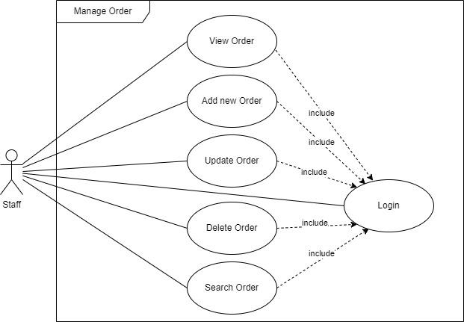

* + 1. **View Order**
* Purpose: this function allows Staff to view information of order.
* Inputs:
* Order view option.
* Outputs: information of order in the **Order** table will be displayed on the screen.
  + 1. **Add new Order**
* Purpose: this function allows Staff to add new orders to the **Order** table.
* Inputs:
* Customer ID
* Product name
* Quantity
* Time order
* Outputs: new order will be added to the **Order** table in the database.
  + 1. **Update Order**
* Purpose: this function allows the Staff to edit the Order’s information.
* Inputs:
* new Customer ID
* new Product name
* new Quantity
* new Time order
* Outputs: new order information will be updated in the **Order** table.
  + 1. **Delete Order**
* Purpose: this function allows the staff to delete order in the **Order** table.
* Inputs:
* Order ID
* Outputs: order will be deleted in the **Order** table.
  + 1. **Search Order**
* Purpose: this function allows the staff to search for the order in the **Order** table.
* Inputs:
* Search input value
* Outputs: the corresponding list of orders in the **Order** table will be displayed on the screen.
  1. **Manage Feedback:** this module allows employees to **view the list of feedback, feedback time and status updates (processed or unprocessed) of customer feedback for products purchased by customers.**
     1. **View Feedback**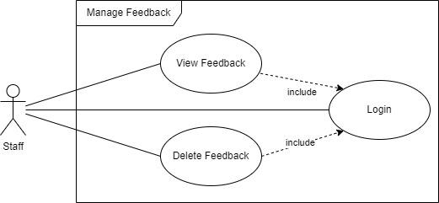
* Purpose: this function allows Staff to view feedback.
* Inputs: choose **View Feedback** option
* Outputs: information of feedback in the **Feedback** table will be displayed on the screen.
  + 1. **Delete Feedback**
* Purpose: this function allows the staff to delete the feedback in the **Feedback** table.
* Inputs:
  + Content
* Outputs: feedback will be deleted in the **Feedback** table.
  1. **Register:** this module allows the Customer to register an account to login to the client application.
* Purpose: this function allows the Customer to register an account and save it to the **Customer** table.
* Inputs:
* Customer name
* Address
* Phone
* Email
* Username
* Password
* Outputs: notice successful account registration. Otherwise, it will report an error and ask the user to re-enter.
  1. **Login:** this module allows the Customer or Staff to login to the client application with a registered account.
* Purpose: This function allows Customer to login to the client application with the account registered in the **Customer** table or the employee to log in with the account in the **Staff** table.
* Inputs:
* Username
* Password
* Outputs: notice successful account login and switch to the client interface. Otherwise, it will report an error and ask the user to re-enter.
  1. **Order:** this module allows the Customer to place order after selecting desired product from client application.
* Purpose: this module allows the Customer to place order after selecting desired product from client application and the order will be saved in the **Order** table.
* Inputs:
* Choose the desired product.
* Choose quantity.
* Outputs: the total amount to be paid will be displayed on the screen. When the user presses Order, the order will be saved to the **Order** table.
  1. **Feedback:** This module allows the Customer to give feedback on the product that the customer has purchased.
* Purpose: help get opinions from customers about the product, or support customers when the product has an error during shipping or a supplier error.
* Inputs:
  + Customer ID
  + Order ID
  + Content
* Outputs: the feedback will be added in the **Feedback** table.

1. **Hardware and Software required for implementing the project**

|  | **Server** | **Client** |
| --- | --- | --- |
| **Hardware** | Operating system | Operating system |
| **Software** | SQL Server 2022, JDK 19, JDBC Driver 12.2, NetBeans IDE 17 | Project App requirements |
| **Additional**  **Technology** |  | |

**CUSTOMER ACCEPTANCE CRITERIA**

| **No.** | **Customer’s Acceptance Criteria** |
| --- | --- |
|  | **Register**: make sure the email is syntactically correct. The phone number must be a number and cannot contain special characters or spaces. Password and confirmation password must match. When the user does not comply with the above content, the system will report an error and ask to re-enter. |
|  | **Login**: when the user enters the wrong email syntax, wrong email or password, the corresponding error message will appear asking the user to re-enter. |
|  | **Categories and products**: each product will be added to a separate category, when the user selects a specific category, the entire corresponding product will be displayed on the screen. |
|  | **Search product**: the search bar appears inside the product page, the user can enter product name or product code and then press the search button, all the corresponding products will be displayed. |
|  | When a user chooses to make a purchase, make sure the user is logged in before making a purchase. If not, the login interface will be displayed for the user to log in. |
|  | Client side application including login, registration, change password, category, product and order functions. |
|  | Staff side application will include login, view products, manage all sales information such as customer information, product information, order information and return information. |
|  | Manager side application will include information management of staff, product suppliers, manage warehouses such as the number of imported products and the number of products sold, thereby controlling supply and demand and sales. |

**PROJECT PLAN**

1. **Project Details**
2. **Name of the Client**: Furniture System.
3. **Date of the Project Plan:** 11/05/2023.
4. **Project Vision/Objectives**:

This system gives general, concise and accurate product related information, product prices and inquiries such as product details, purchases, order details, account information, customer information, staff information,..

1. **Scope:**

The scope of the project includes a manager, multiple employees and customers. The manager manages information about employees, suppliers, warehouses, product imports. Employees manage customers, products in the store, orders and promotions, etc. Customers will buy products through a dedicated application for customers.

1. **Our understanding of the client organization**:

The software includes information about all available products, prices, orders and staff. With 4 main business processes including: Manage information: make it easier to manage information, accounts of customers and employees. Make accessing, editing and looking up convenient, saving time; Category management: products will be divided into appropriate categories. Customers will search for products on the search bar, the system will take customers to products that match their needs. Each product has a detailed description, price, quantity. Sales management: the customer adds products to the cart, the system goes to the payment page, the customer chooses a payment method, fills in customer information, etc., after the customer places an order, the system will record all the information and transfer it to the order management department, the staff will manage the order, prepare the order and transfer the product to the warehouse for shipping. In this operation, the system will help customers pay simply and quickly and help staff manage orders easily; Warehouse management: managing import and export products in the warehouse helps manage products in the warehouse clearly and easily associated with the products listed for sale.

1. **Project Organization with Responsibilities and Authorities:**

| No | Member | Roles | Responsibilities |
| --- | --- | --- | --- |
| 1 | Pham Bao Quoc | Leader | Completing the process of entering products into the warehouse, managing warehouse information, total quantity of products in each warehouse, managing supplier information. |
| 2 | Nguyen Ngoc Bao Thi | Member | Complete the process of adding, editing, deleting and searching for products integrated into the customer interface, managing products by category, and making statistics on product quantity. |
| 3 | Nguyen Minh Tri Duc | Member | Complete the purchase process from the moment the customer selects the product, adds the product to the cart and makes the payment, manages information related to the order. |
| 4 | Nguyen Duong Kieu Diem Quynh | Member | Complete the process of login, registration, account information management and personal information |

1. **Project Initiation/Requirement Documents**

* The application will have two logins: staff login and customer login. If the customer

unregistered, customers will register an account through the registration function, the staff's account will be provided by the manager, and should provide the link for the same.

* It will have option for product details in which various categories should be

provided like household furniture, hospital, shopping mall, college etc.

* Registered customers should be able to log in through their username and password.
* Each product, staff and category should have a unique id.
* Management can add, update and delete employee details,

supplier, etc.

* Details of the order placed by the customer and the price should be

maintained i.e. add, update and delete.

* Order details of the product should be maintained.
* Stock of various products should be maintained.
* Proper validation should be applied to run the application according to the

requirement of the management like if the username or password is not the

user should not able to login, user should not able to do any updating or

deletion etc.

1. **Deliverables**

* Design Document
* Document Form
* Installation Manual
* User Manual

1. **Project Dependencies**

* Each member clearly understands his or her mission in the project.
* Interaction between members when there is a problem to find a way to fix it.
* Lost data

1. **Major Project Milestones**

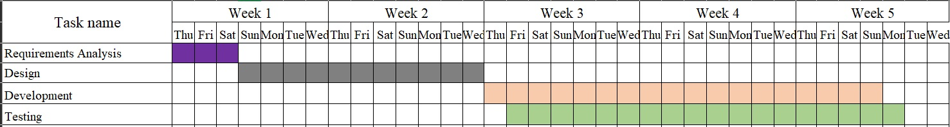

1. **Quality Plan**
2. **Review Activities**:

* **First time:**
* **Meeting day**: 15/05/2023
* **Activity**: assign work, exchange collected documents related to the topic.
* **Target**: complete the work assignment, understand the duties of each member.
* **Second time:**
* **Meeting day**: 23/05/2023
* **Activity**: exchange documents, check the completion progress of each member, modify and add content.
* **Target**: complete the content and reach agreement on the content among the members.
* **Third time:**
* **Meeting day**: 24/05/2023
* **Activity**: exchange documents, check the completion progress of each member, modify and add content; exchange documents, check the completion progress of each member, edit and add content, orient the interface of the application, list each specific function.
* **Target**: complete the content and reach agreement on the content among the members.
* **Fourth time:**
* **Meeting day:** 01/06/2023
* **Activity:** discuss the database to make changes and additions.
* **Target:** complete the database and start programming.

1. **Testing Activities** (Final Test)

* Unit Test

1. **Backup and Recovery Strategies**

* Hard Disk Drive
* Google Drive

**ARCHITECTURE & GUI STANDARD OF APPLICATION**

1. **Architecture of Application**
2. **GUI Standard Application**

| **Property** | **Value** |
| --- | --- |
| Document Theme and Color Scheme | Furniture System |
| Form - Background Color | #EEE9E9 |
| Title - Font Size | 25px |
| Title - Font Color | #000000 |
| Title - Font Style | Candara |
| Title - Alignment | Center |
| Background color of Controls on the form | #00FFFF |
| Foreground color of Controls on the form | #FFFFFF |
| Control Caption - Font Size | 15px |
| Control Caption - Font Color | #000000 |
| Control Caption - Font Style | Candara |
| Control caption and controls - Alignment | Center |
| Command button - Alignment | Center |

**INTERFACE DESIGN DOCUMENT**

List of forms to be created

1. **Document Name: System Management**
   1. **Description: There are 2 buttons including 1 for manage, 1 for staff. when pressing the manage button, it will ask to enter the manager's pin code, if entered correctly, it will go to the manage interface, when clicking the staff button, the login interface will be displayed, when the login is successful The function display interface for staff will appear on the screen.**
   2. **Controls on the Document:**
   3. **UI design:**

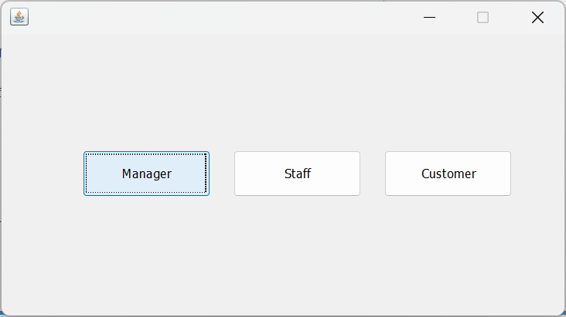

1. **Document Name: Manage** 
   1. **Description: Manage functions.**
   2. **Controls on the Document:**
   3. **UI design:**

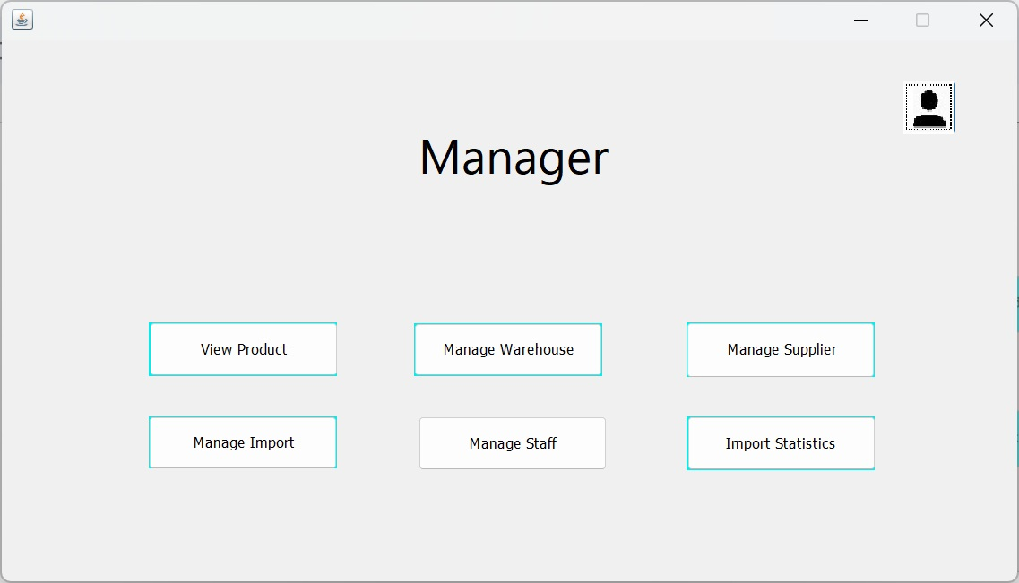

1. **Document Name: Product**
   1. **Description: Allows manage to view details of products being sold.**
   2. **Controls on the Document:**
   3. **UI design:**

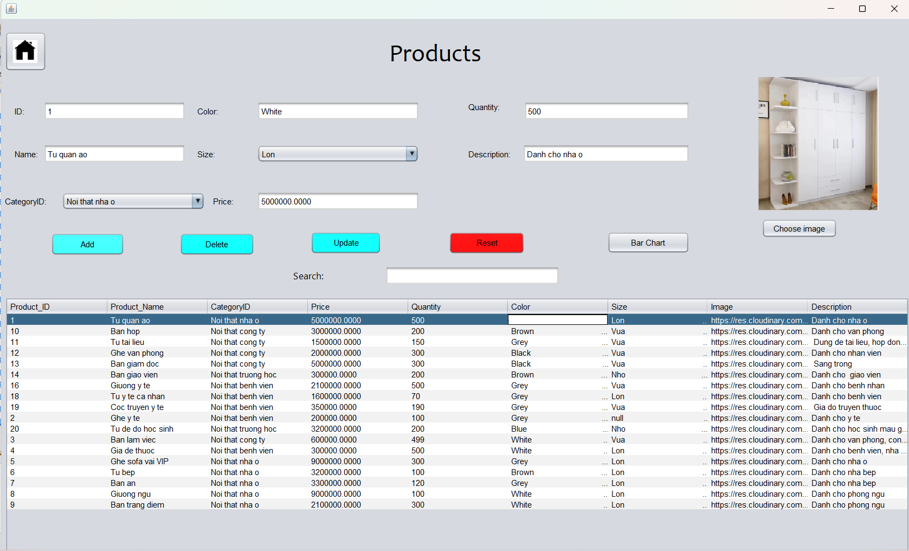

1. **Document Name: Order**
   1. **Description: Allows manage to view orders.**
   2. **Controls on the Document:**
   3. 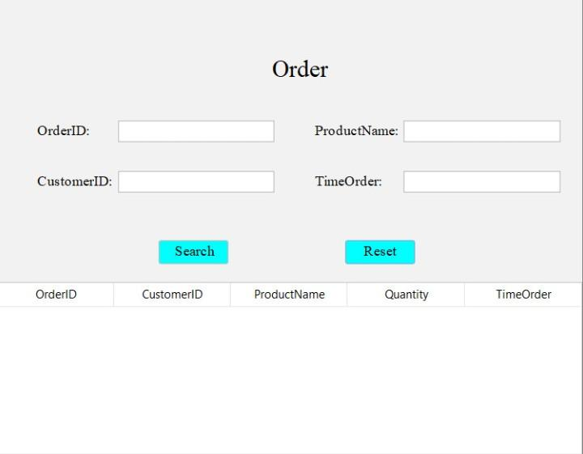**UI design:**
2. **Document Name: Manage Supplier**
   1. **Description: Allows management to add, edit supplier.**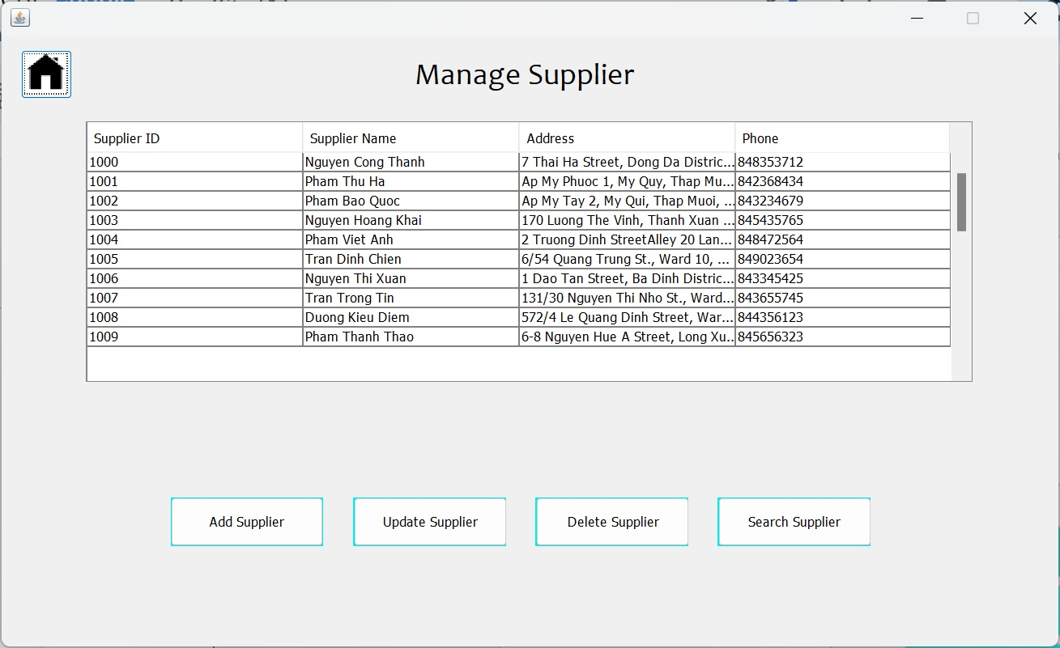
   2. **Controls on the Document:**
   3. **UI design:**
3. **Document Name: Manage Supplier**
   1. **Description: Allows management to delete supplier.**
   2. **Controls on the Document:**
   3. **UI design:**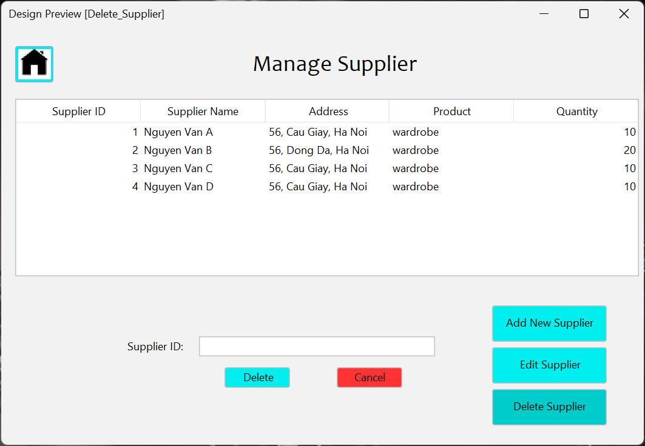
4. **Document Name: Revenue**
   1. **Description: Allows manage to view total sales by day.**
   2. **Controls on the Document:**
   3. **UI design:**

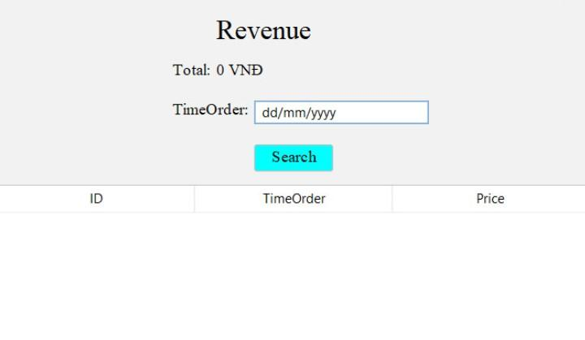

1. **Document Name: Staff**
   1. **Description: Staff functions.**
   2. **Controls on the Document:**
   3. 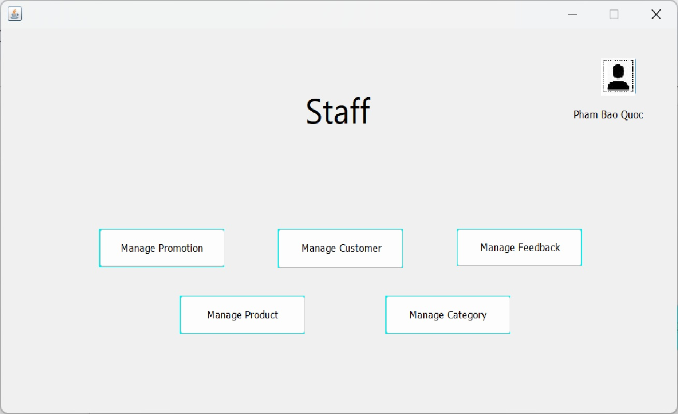**UI design:**
2. **Document Name: Category**
   1. **Description: Allow staff to update product category.**
   2. **Controls on the Document:**
   3. **UI design:**

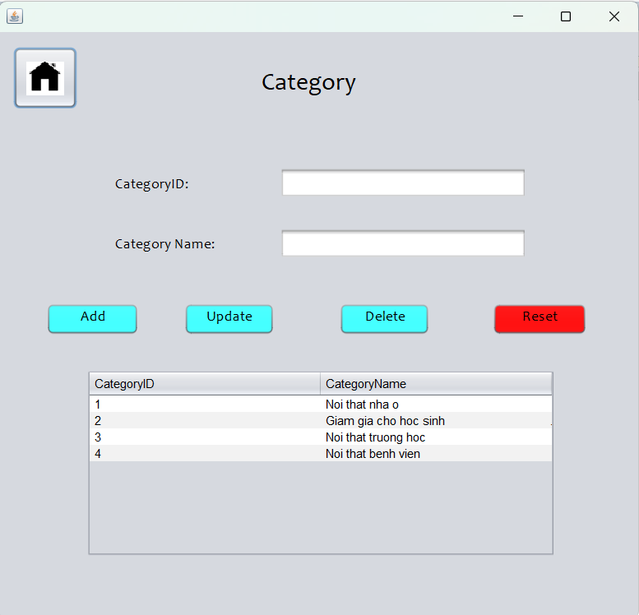

1. **Document Name: Login**
   1. **Description: User can login to the system with the account registered in the system.**
   2. **Controls on the Document:**
   3. **UI design:**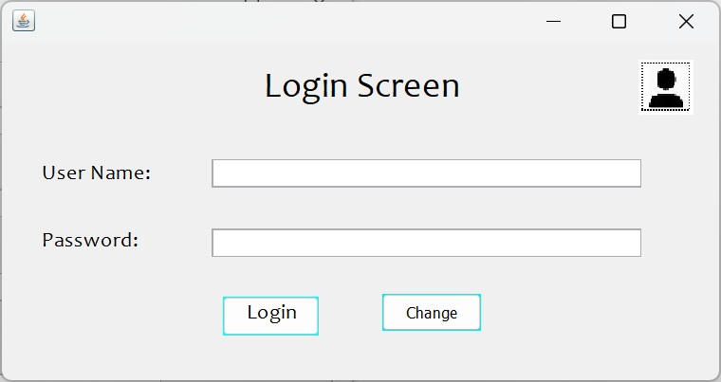
2. **Document Name: Register**
   1. **Description: Sign up for an account.**
   2. **Controls on the Document:**
   3. **UI design:**

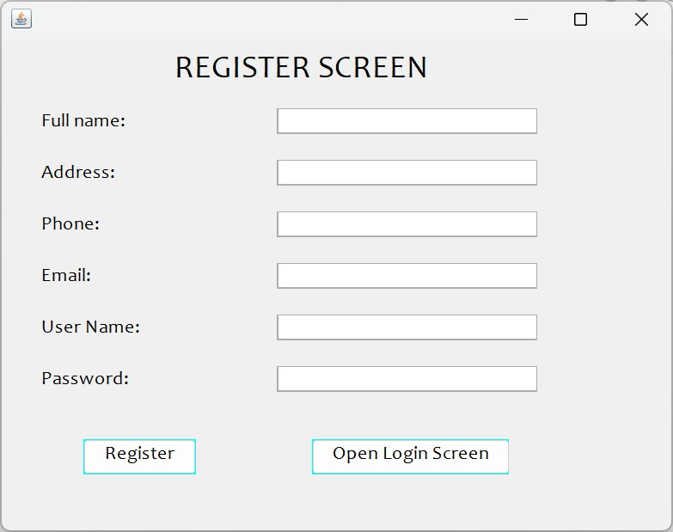

1. **Document Name: Forgot Password**
   1. **Description: Change the new password when the user forgets the password.**
   2. **Controls on the Document:**
   3. **UI design:**

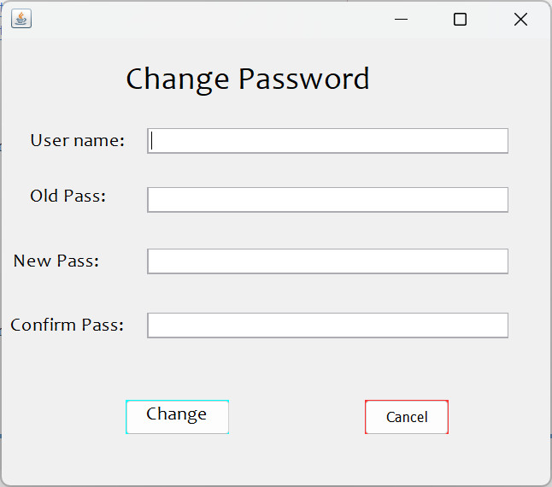

1. **Document Name: Customer management**
   1. **Description: Enter customer information.**
   2. **Controls on the Document:**
   3. **UI design:**

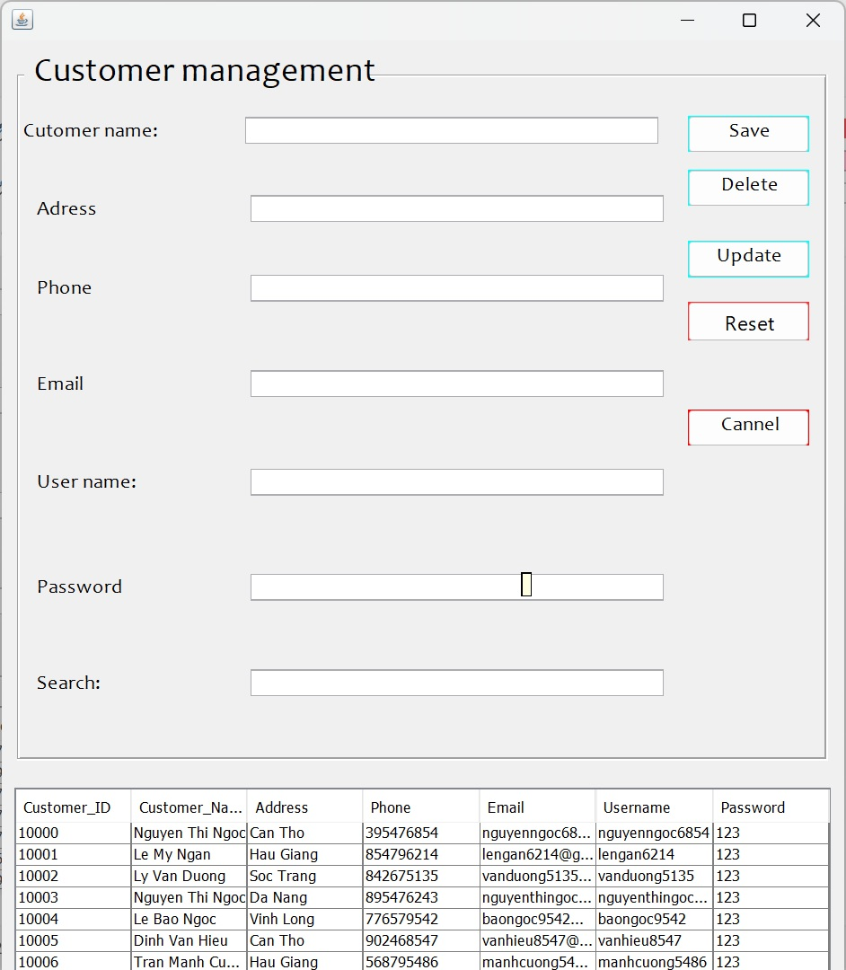

1. **Document Name: Login Manager**
   1. **Description: Manager's login.**
   2. **Controls on the Document:**
   3. **UI design:**

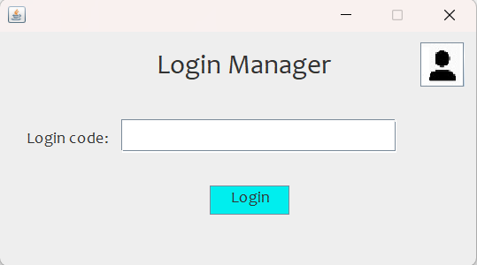

1. **Document Name: Employee managerment**
   1. **Description: Enter employee information.**
   2. **Controls on the Document:**
   3. **UI design:**

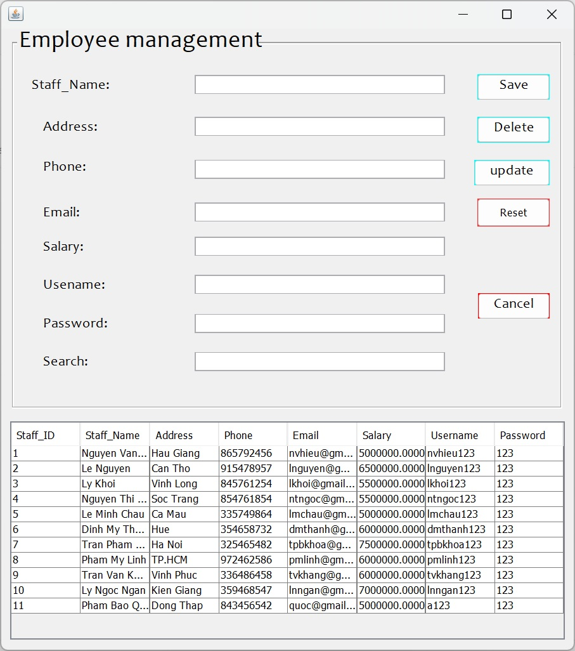

1. **Document Name: Feedback**
   1. **Description: Enter customer information.**
   2. **Controls on the Document:**
   3. **UI design:**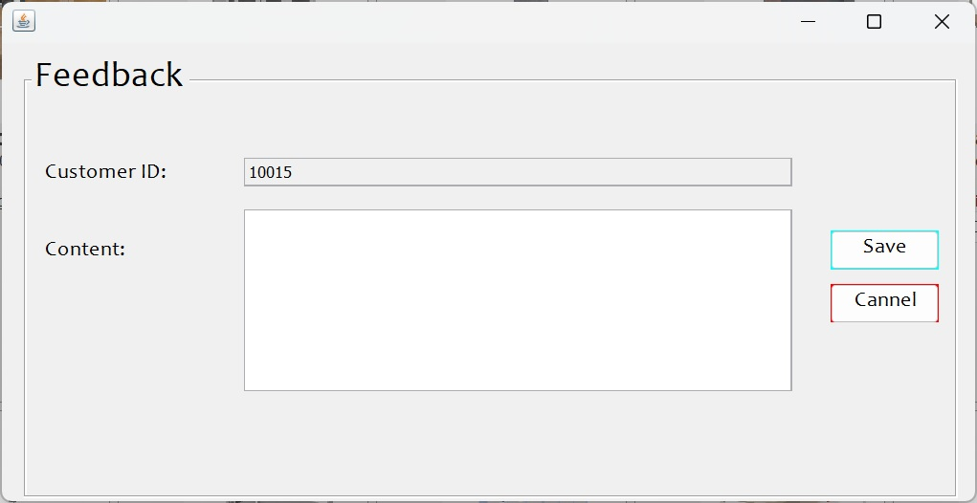
2. **Document Name: Feedback management**
   1. **Description: Manage customer feedback.**
   2. **Controls on the Document:**
   3. **UI design:**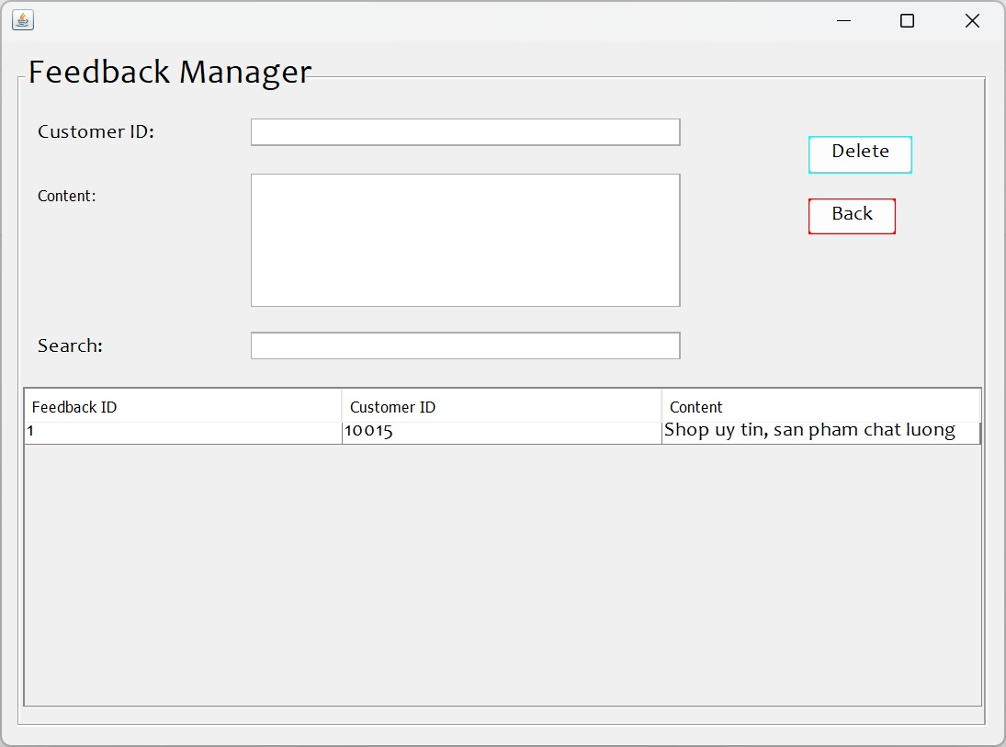
3. **Document Name: Promotion**
   1. **Description: Promotional events for customers.**
   2. **Controls on the Document:**
   3. **UI design:**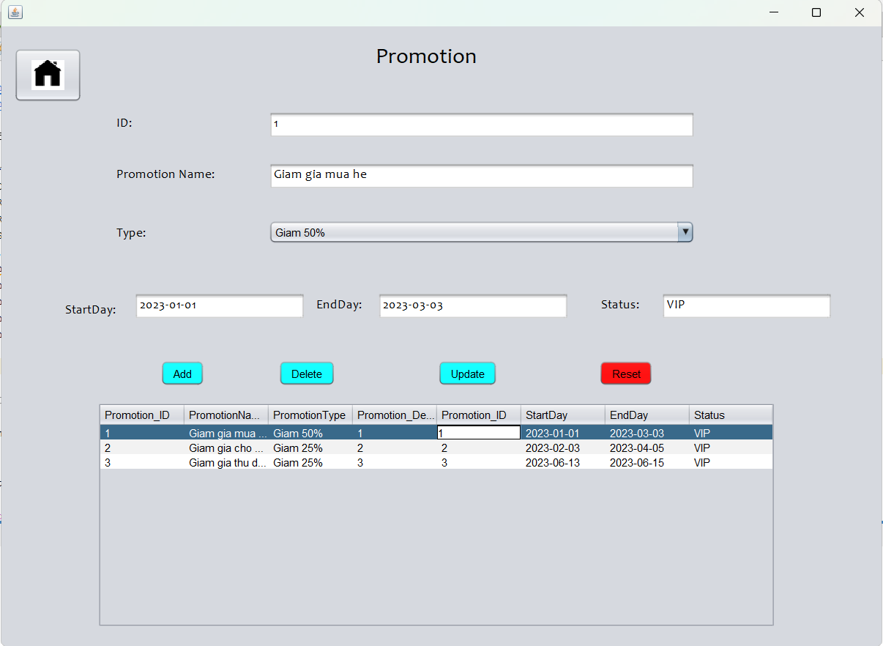
4. **Document Name: Manage view Product**
   1. **Description: Promotional events for customers.**
   2. **Controls on the Document:This is the product view of the manager, the manager can view and search for the product.**
   3. **UI design:**

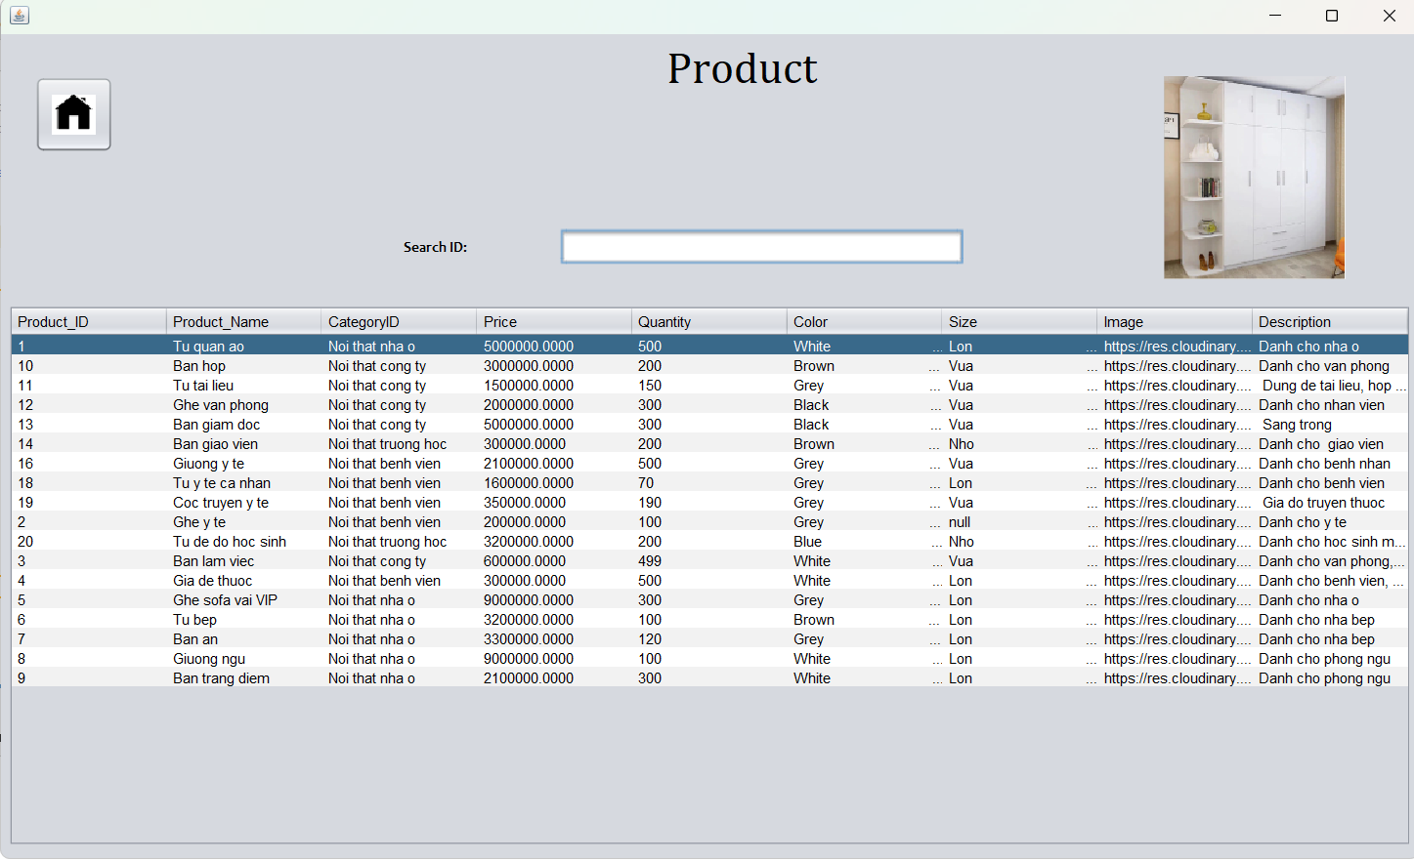

**DATABASE DESIGN DOCUMENT**

**I. ER/Class Diagram**

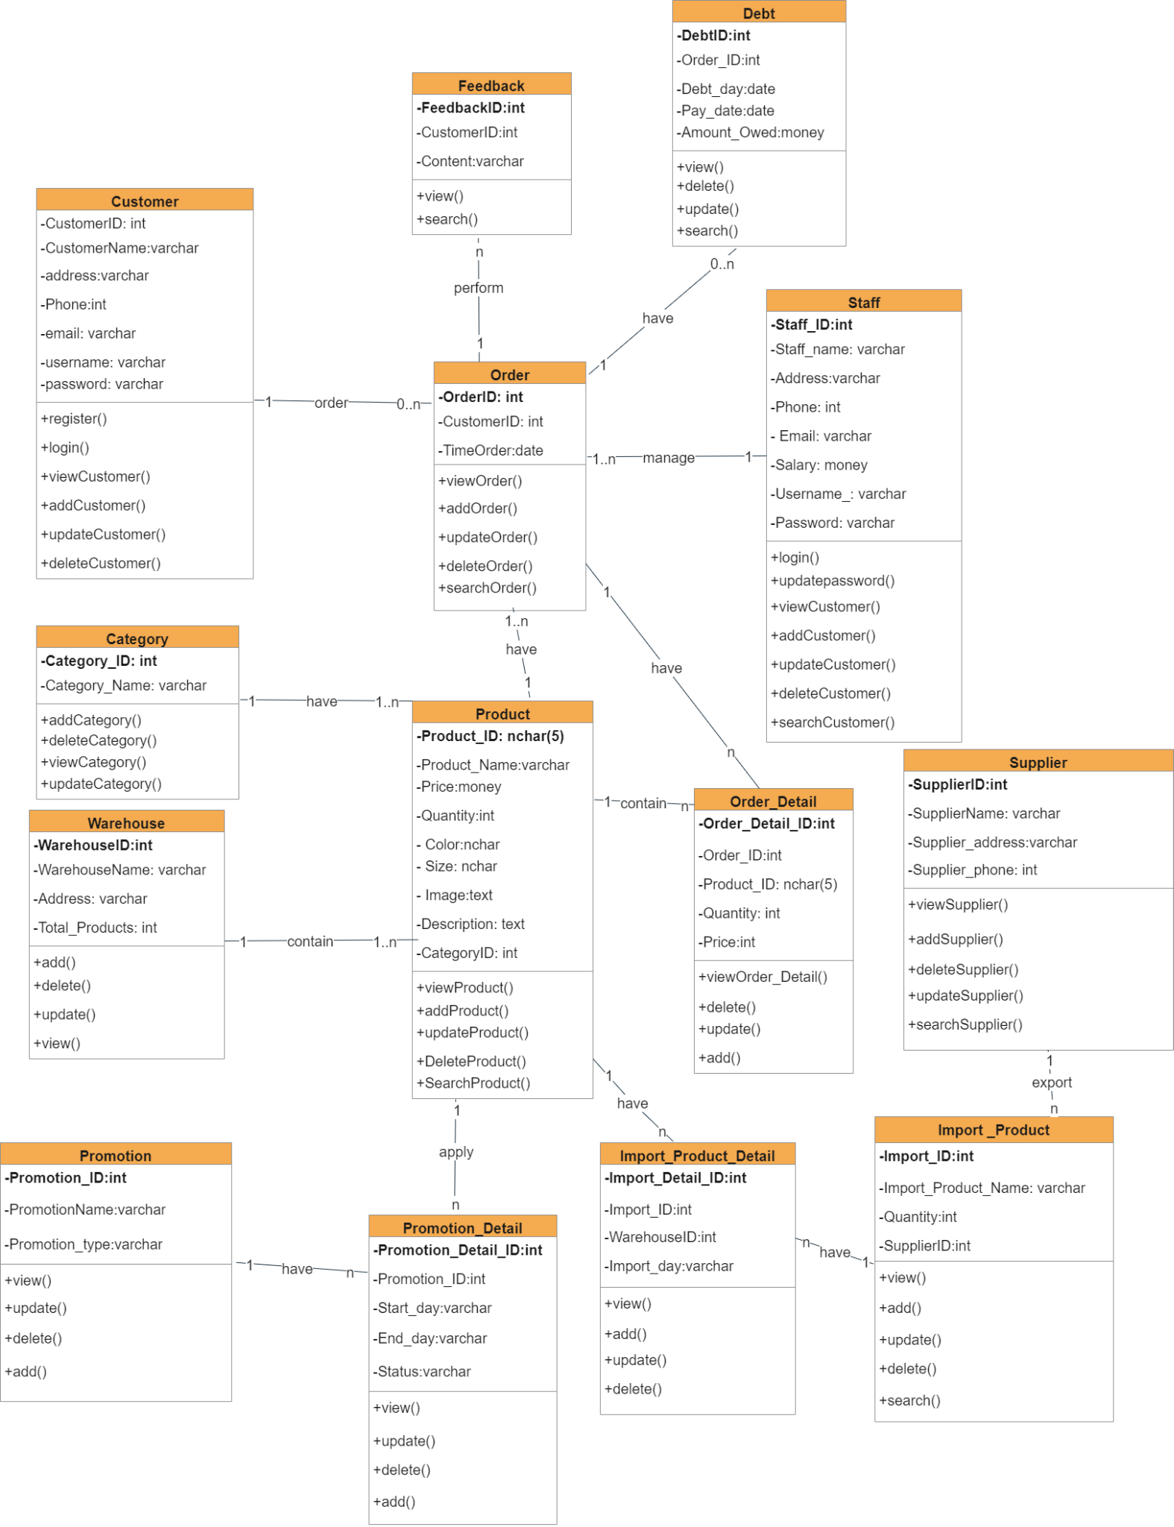

**II. Table Description**

| **Customer** | | | |
| --- | --- | --- | --- |
| **Field Name** | **Data Type** | **Constraint  (Primary Key, Foreign Key, Identity, Not Null,...)** | **Description** |
| CustomerID | int | Primary Key, Identity | ID of Customer |
| CustomerName | varchar(255) | Not null | Name of Customer |
| Address | varchar(255) | Not null | Address of Customer |
| Phone | int | Not null | Phone of Customer |
| Email | varchar(255) | Not null | Email of Customer |
| Username | varchar(255) | Not null | Username of Customer (use to login account) |
| Password | varchar(255) | Not null | Password of Customer (use to login account) |

| **Staff** | | | |
| --- | --- | --- | --- |
| **Field Name** | **Data Type** | **Constraint  (Primary Key, Foreign Key, Identity, Not Null,...)** | **Description** |
| Staff_ID | int | Primary Key, Identity | ID of Staff |
| Staff_Name | varchar(255) | Not null | Name of Staff |
| Address | varchar(255) | Not null | Address of Staff |
| Phone | int | Not null | Phone of Staff |
| Email | varchar(255) | Not null | Email of Staff |
| Salary | money | Not null | Salary of Staff |
| Username | varchar(255) | Not null | Username of Staff  ( Used to log in to the management system) |
| Password | varchar(255) | Not null | Password of Staff  (used to login to the management system) |

| **Product** | | | |
| --- | --- | --- | --- |
| **Field Name** | **Data Type** | **Constraint  (Primary Key, Foreign Key, Identity, Not Null,...)** | **Description** |
| ProductID | nchar(5) | Primary Key | ID of Product |
| ProductName | varchar(255) | Not null | Name of Product |
| Price | money | Not null | Price of Product |
| Quantity | int | Not null | Quantity of Product |
| Color | nchar(50) | Not null | Color of Product |
| Size | nchar(50) | Not null | Size of Product |
| Image | text | Not null | Image of Product |
| Description | text | Not null | Description of Product |
| CategoryID | int | Not null | Product in Category |

| **Warehouse** | | | |
| --- | --- | --- | --- |
| **Field Name** | **Data Type** | **Constraint  (Primary Key, Foreign Key, Identity, Not Null,...)** | **Description** |
| WarehouseID | int | Primary Key | ID of Warehouse |
| WarehouseName | varchar(255) | Not null | Name of Warehouse |
| Address | varchar(255) | Not null | Address of Warehouse |
| Total_Products | int | Not null | Total products in Warehouse |

| **Order** | | | |
| --- | --- | --- | --- |
| **Field Name** | **Data Type** | **Constraint  (Primary Key, Foreign Key, Identity, Not Null,...)** | **Description** |
| OrderID | int | Primary Key, Identity | ID of Order |
| CustomerID | int | Not null | ID of Customer |
| TimeOrder | date | Not null | TimeOrder |

| **Order_Detail** | | | |
| --- | --- | --- | --- |
| **Field Name** | **Data Type** | **Constraint  (Primary Key, Foreign Key, Identity, Not Null,...)** | **Description** |
| Order_Detail_ID | int | Primary Key, Identity | ID of Order Detail |
| Order_ID | int | Not null | ID of Order |
| Product_ID | Nchar(5) | Not null | ID of Product |
| Quantity | int | Not null | Number of products in the order. |
| Price | int | Not null | Price of Product in Order |

| **Category** | | | |
| --- | --- | --- | --- |
| **Field Name** | **Data Type** | **Constraint  (Primary Key, Foreign Key, Identity, Not Null,...)** | **Description** |
| Category_ID | int | Primary Key | ID of Category |
| Category_Name | varchar(255) | Not null | Name of Category |

| **Supplier** | | | |
| --- | --- | --- | --- |
| **Field Name** | **Data Type** | **Constraint  (Primary Key, Foreign Key, Identity, Not Null,...)** | **Description** |
| SupplierID | int | Primary Key | ID of Supplier |
| SupplierName | varchar(255) | Not null | Name of Supplier |
| Supplier_address | varchar(255) | Not null | Address of Supplier |
| Supplier_phone | int | Not null | Phone of Supplier |

| **Promotion_Detail** | | | |
| --- | --- | --- | --- |
| **Field Name** | **Data Type** | **Constraint  (Primary Key, Foreign Key, Identity, Not Null,...)** | **Description** |
| Promotion_Detail_ID | int | Primary Key | ID of Promotion Detail |
| Promotion_ID | int | Not null | ID of Promotion |
| Start_day | varchar(255) | Not null | Promotion start date |
| End_day | varchar(255) | Not null | Promotion end date |
| Status | varchar(255) | Not null | VIP codes and regular codes |

| **Promotion** | | | |
| --- | --- | --- | --- |
| **Field Name** | **Data Type** | **Constraint  (Primary Key, Foreign Key, Identity, Not Null,...)** | **Description** |
| Promotion_ID | int | Primary Key | ID of Promotion |
| PromotionName | varchar(255) | Not null | Name of Promotion |
| Promotion_type | varchar(255) | Not null | Type of Promotion |

| **Import_Product** | | | |
| --- | --- | --- | --- |
| **Field Name** | **Data Type** | **Constraint  (Primary Key, Foreign Key, Identity, Not Null,...)** | **Description** |
| Import_ID | int | Primary Key | ID of import product |
| ImportProductName | varchar(255) | Not null | Name of import Product |
| Quantity | int | Not null | Quantity of imported products |
| SupplierID | int | Not null | ID of Supplier |

| **Import_Product_Detail** | | | |
| --- | --- | --- | --- |
| **Field Name** | **Data Type** | **Constraint  (Primary Key, Foreign Key, Identity, Not Null,...)** | **Description** |
| Import_Detail_ID | int | Primary Key, Identity | ID of import product detail |
| Import_ID | int | Not null | ID of import product |
| WarehouseID | int | Not null | ID of Warehouse |
| Import_day | varchar(50) | Not null | Import date |

| **Feedback** | | | |
| --- | --- | --- | --- |
| **Field Name** | **Data Type** | **Constraint  (Primary Key, Foreign Key, Identity, Not Null,...)** | **Description** |
| FeedbackID | int | Primary Key | ID of feedback |
| CustomerID | int | Not null | ID of Customer |
| Content | varchar(255) | Not null | Content feedback |

| **Debt** | | | |
| --- | --- | --- | --- |
| **Field Name** | **Data Type** | **Constraint  (Primary Key, Foreign Key, Identity, Not Null,...)** | **Description** |
| DebtID | int | Primary Key, Identity | ID of Debt |
| Order_ID | int | Not null | ID of Order |
| Debt_day | date | Not null | Debt date |
| Pay_date | date | Not null | Pay date |
| Amount_Owed | money | Not null | Amount owed by customer |

**PROCESS DESIGN DOCUMENT**

(Activity diagram, sequence diagram)

1. Process Name: Register

Process Description and Details:

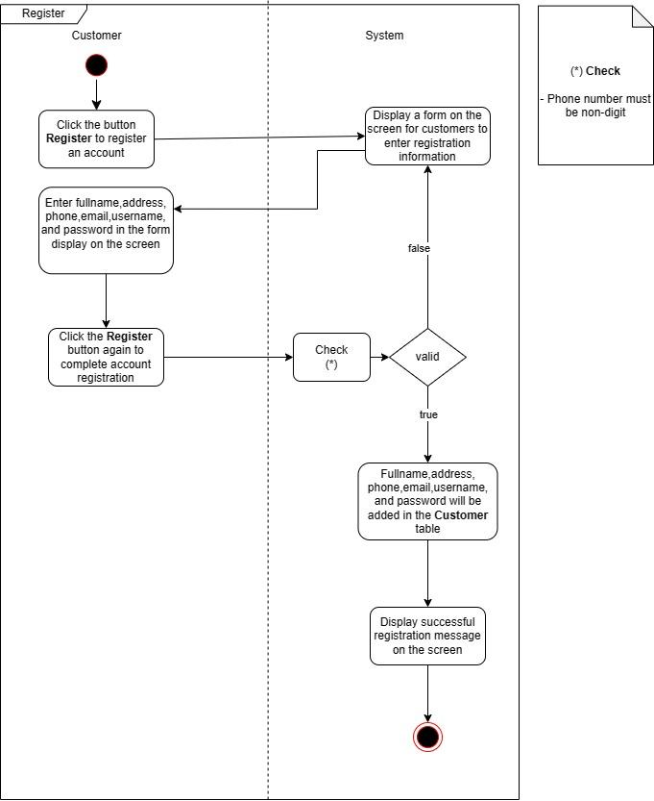



1. Process Name: Customer Login

Process Description and Details: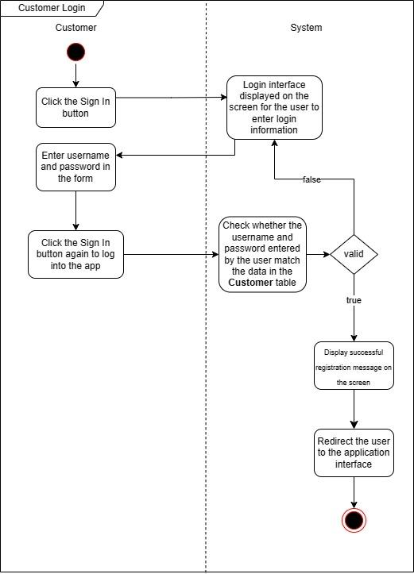

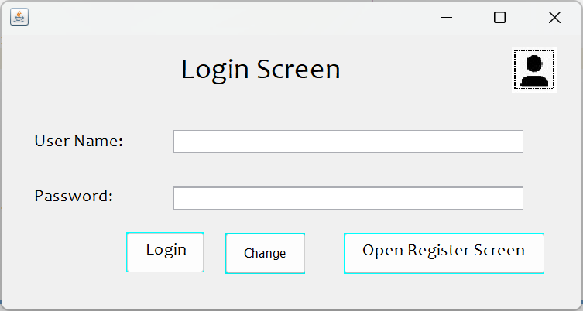

1. Process Name: Change password customer

Process Description and Details:

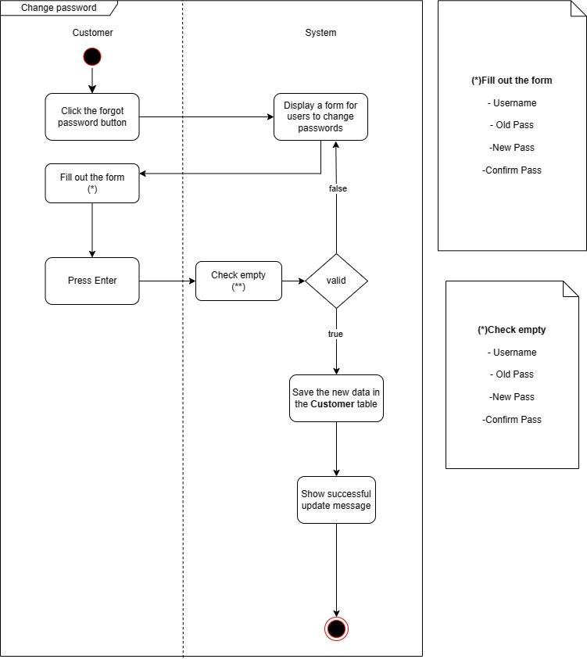



1. Process Name: Change password staff

Process Description and Details:

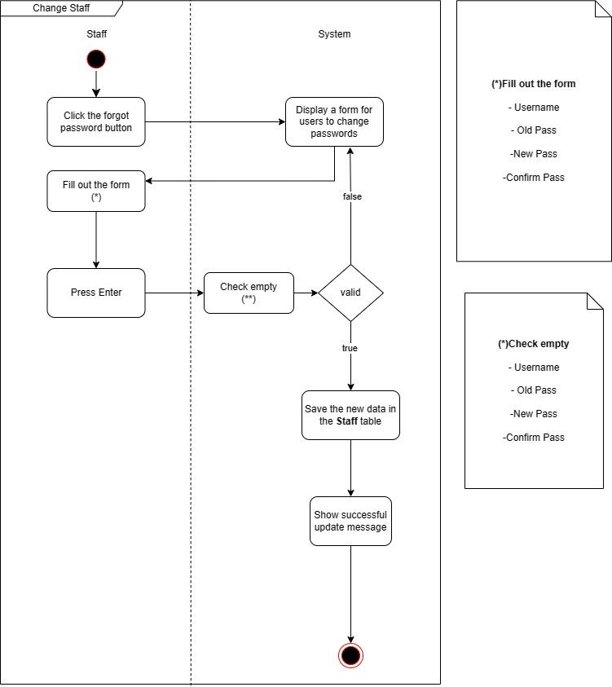



1. Process Name: Feedback

Process Description and Details: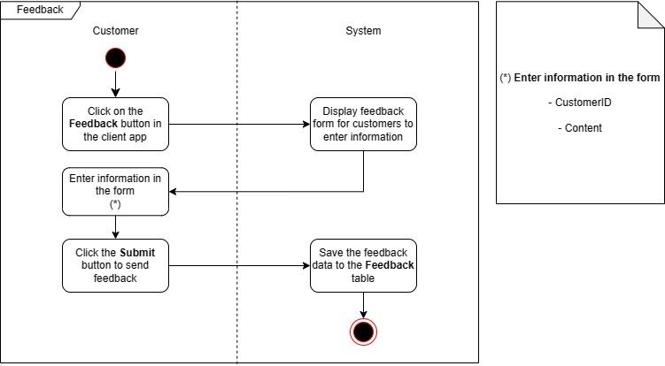



1. Process Name: Staff Login

Process Description and Details:

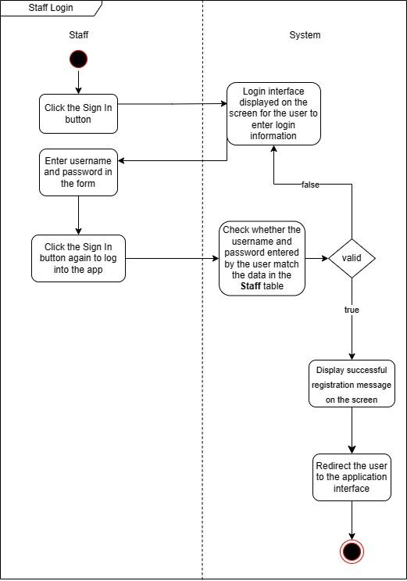



1. Process Name: View Staff

Process Description and Details:

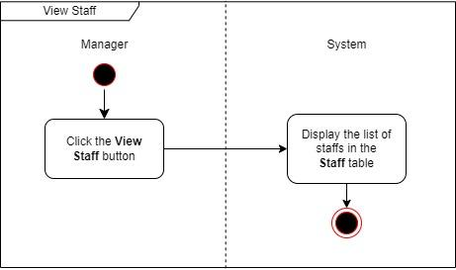

1. Process Name: Add new Staff

Process Description and Details:

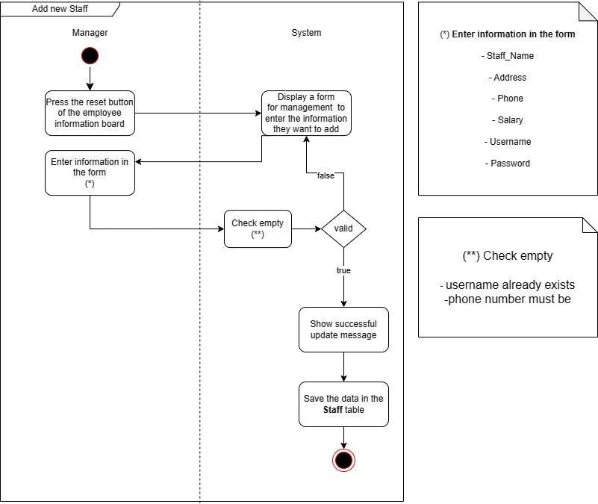

1. Process Name: Update Staff

Process Description and Details:

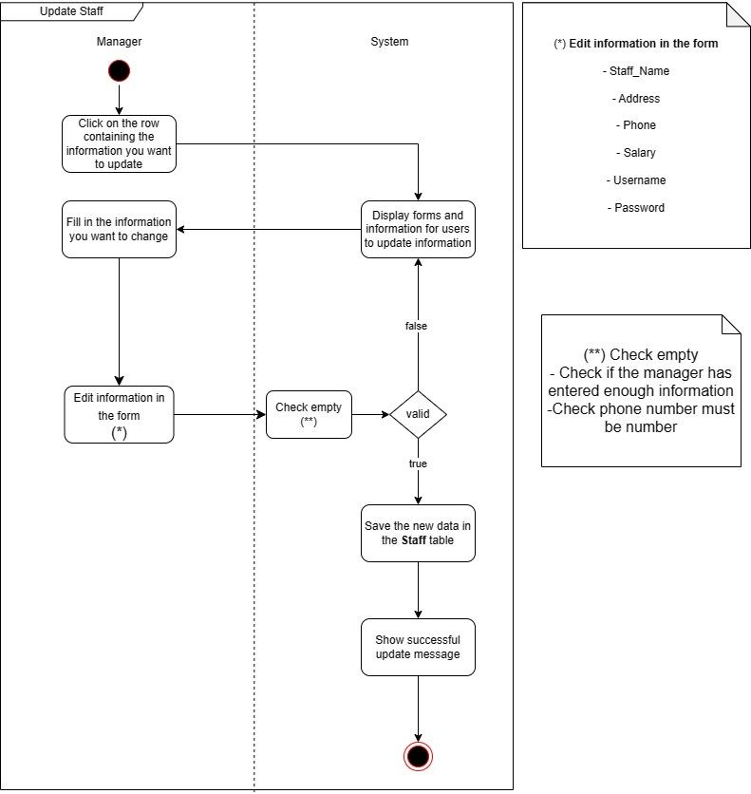

1. Process Name: Delete Staff

Process Description and Details:

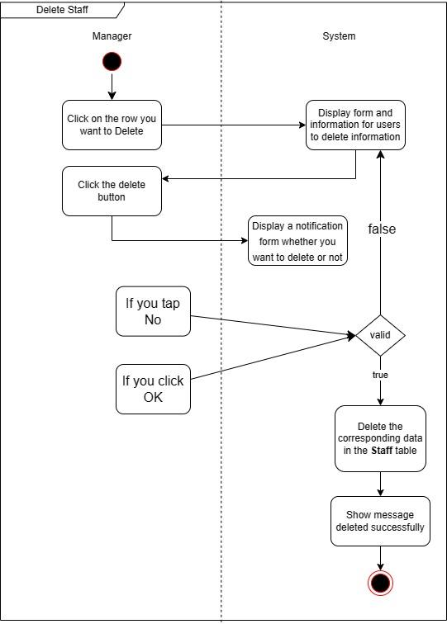

1. Process Name: Search Staff

Process Description and Details:

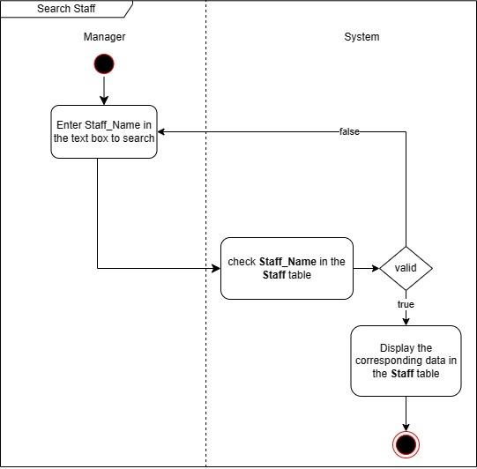

1. Process Name: View Customer

Process Description and Details:

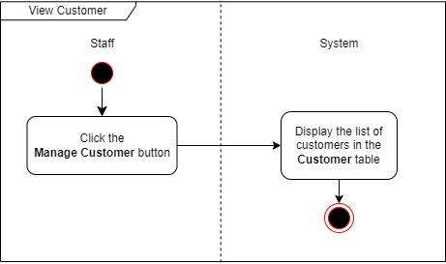

1. Process Name: Add new Customer

Process Description and Details:

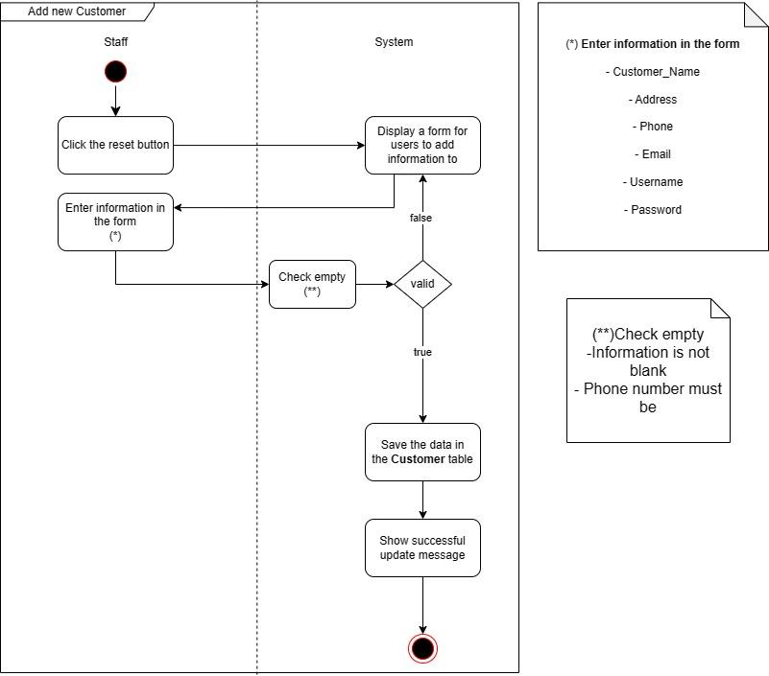

1. Process Name: Update Customer

Process Description and Details:

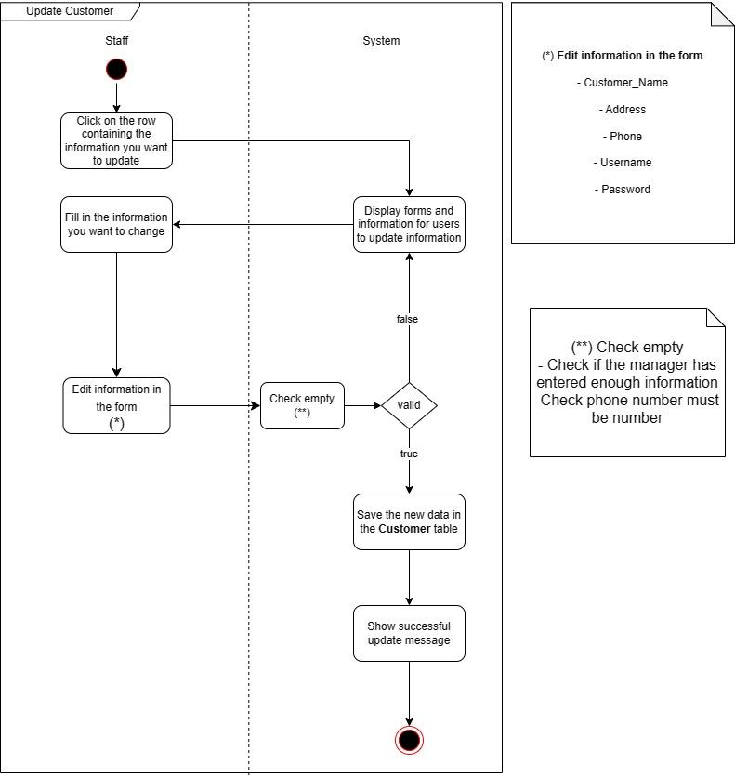

1. Process Name: Delete Customer

Process Description and Details:

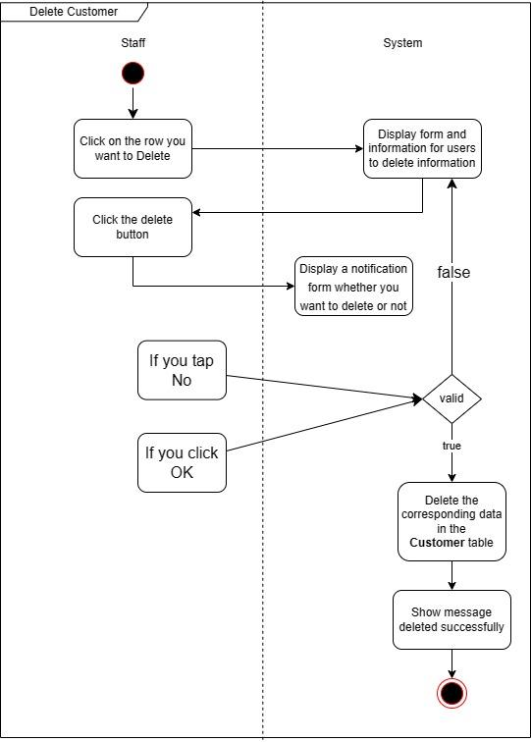

1. Process Name: Search Customer

Process Description and Details:

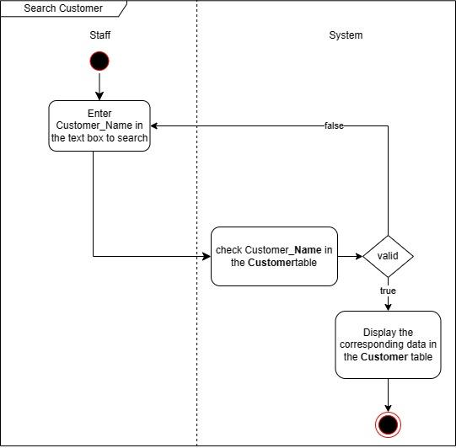

1. Process Name: View Feedback

Process Description and Details:

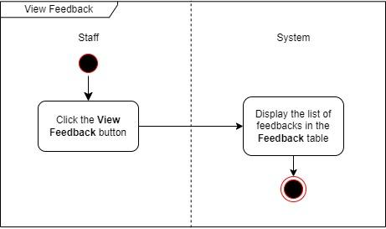

1. Process Name: Delete Feedback

Process Description and Details:

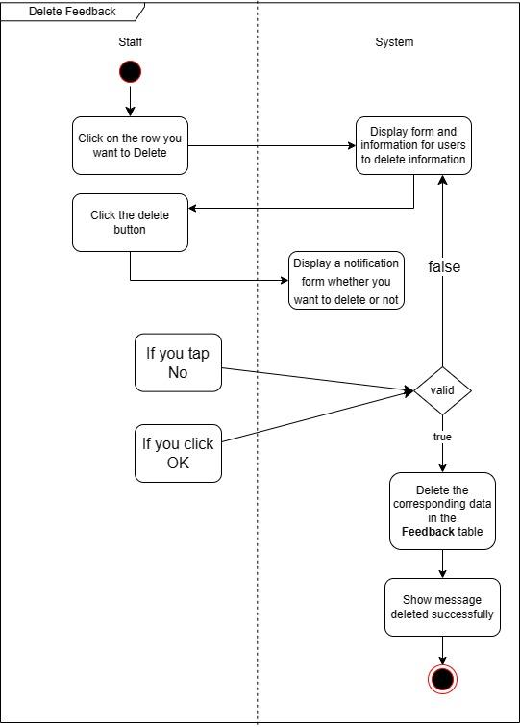

1. Process Name: Order

Process Description and Details:

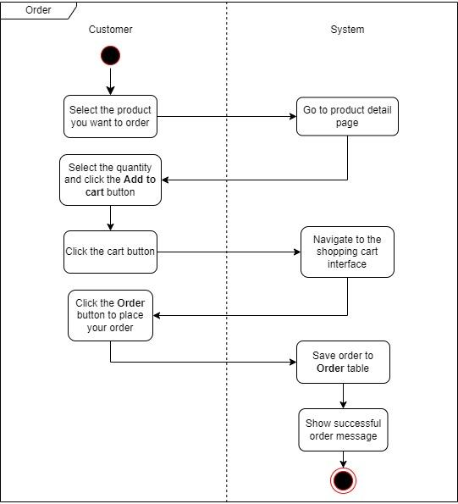

1. Process Name: View Import Products

Process Description and Details:

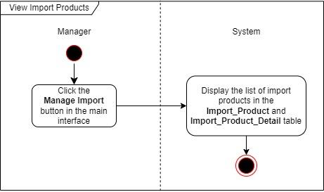

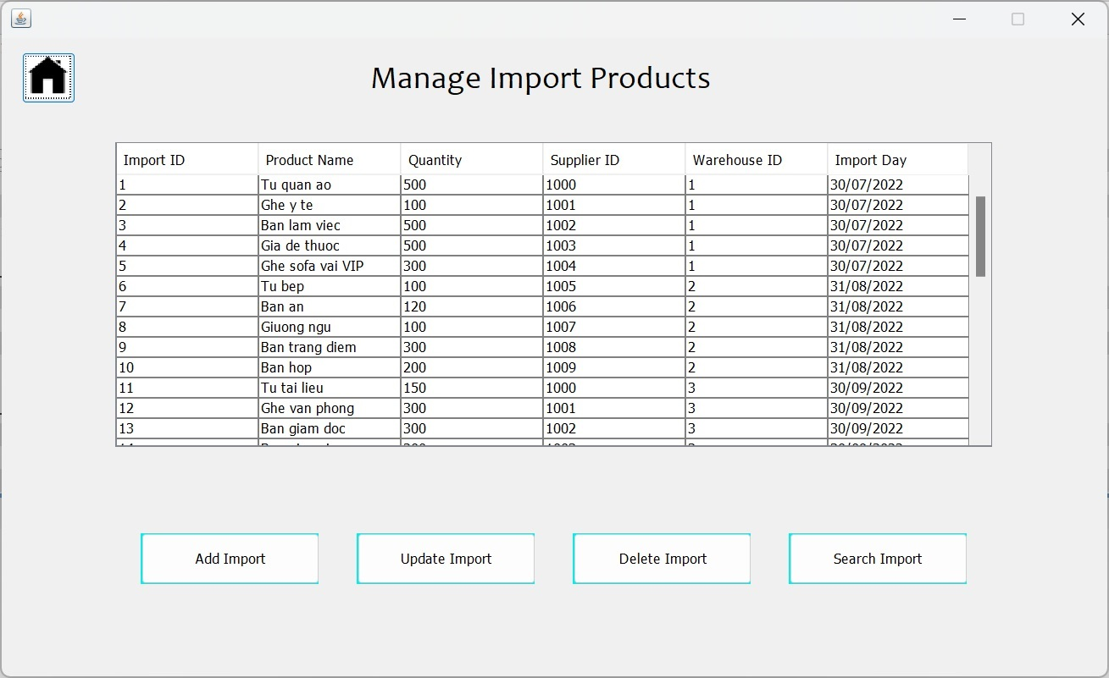

1. Process Name: Add New Import Products

Process Description and Details:

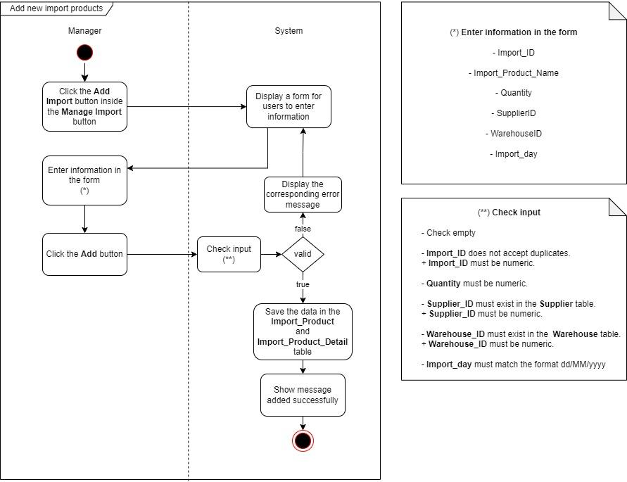

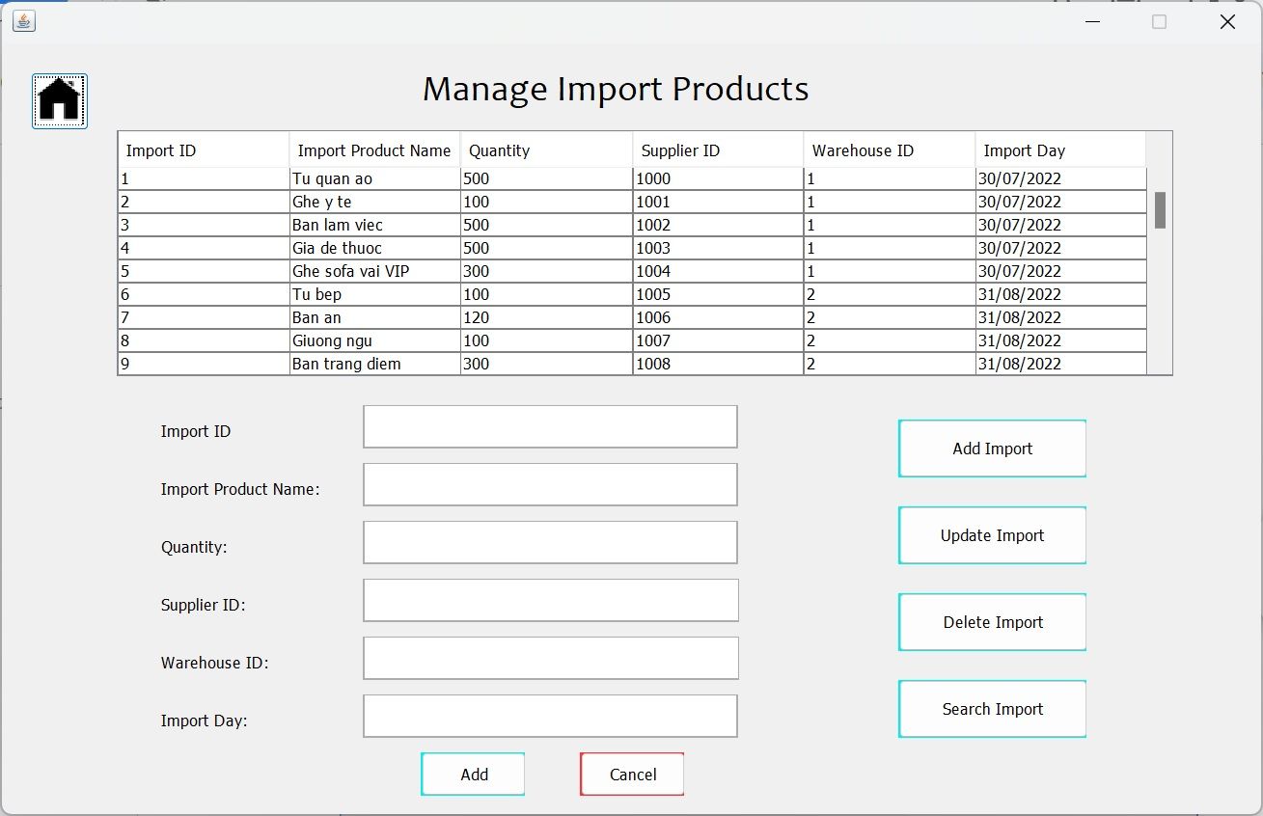

1. Process Name: Update Import Products

Process Description and Details:

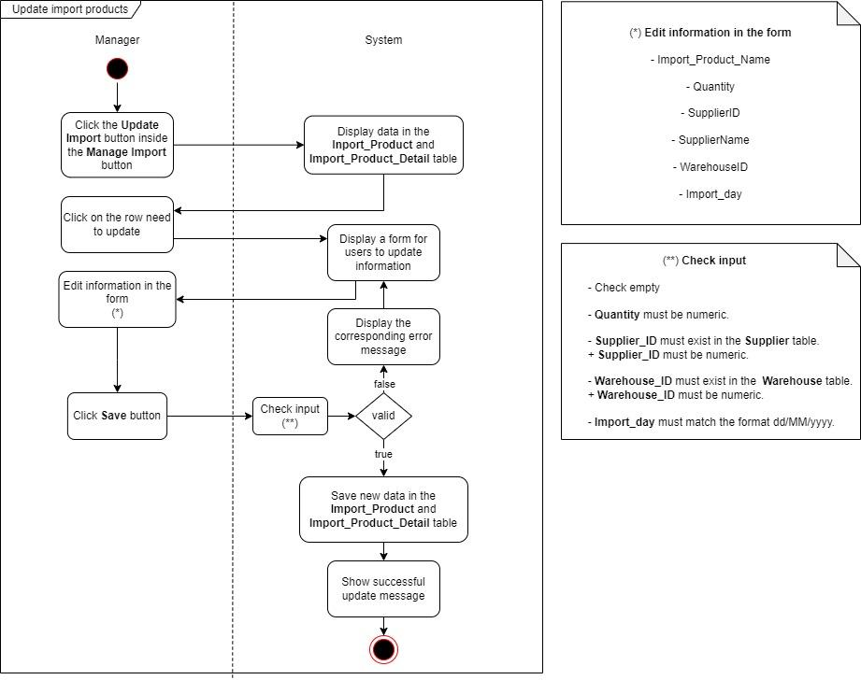

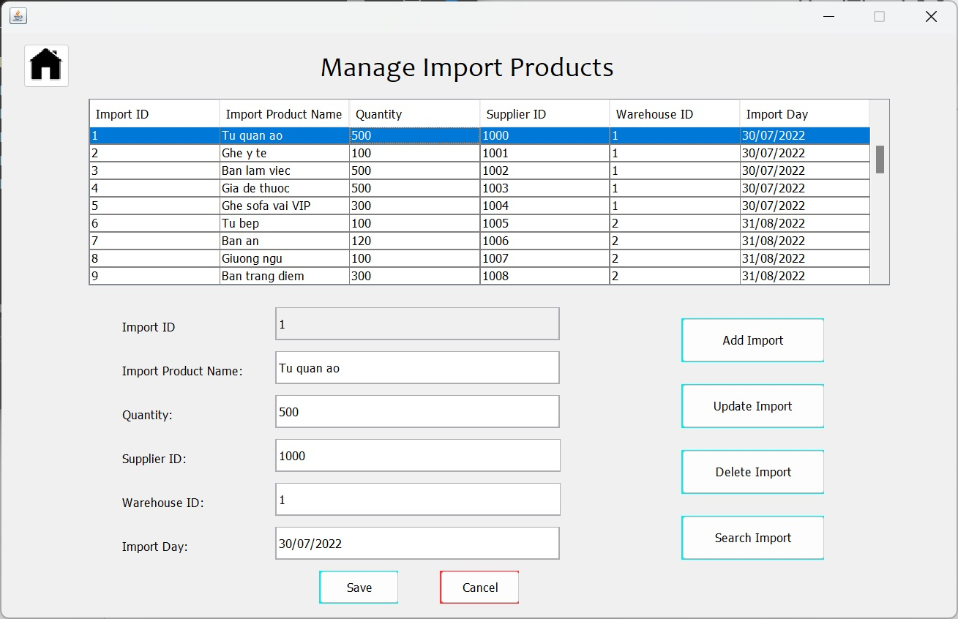

1. Process Name: Delete Import Products

Process Description and Details:

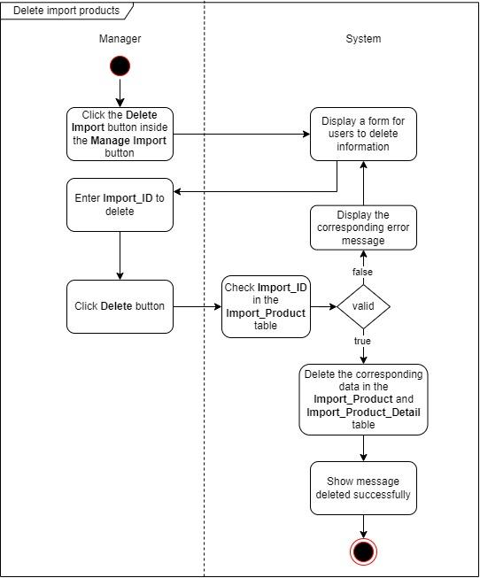

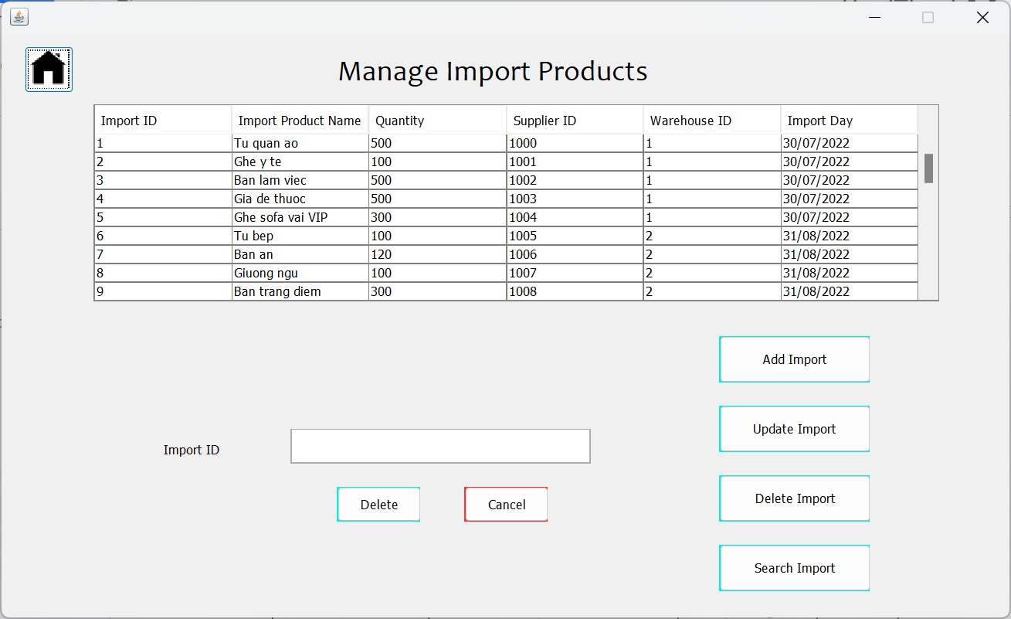

1. Process Name: Search Import Products

Process Description and Details:

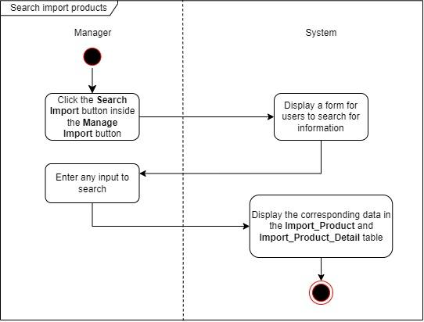

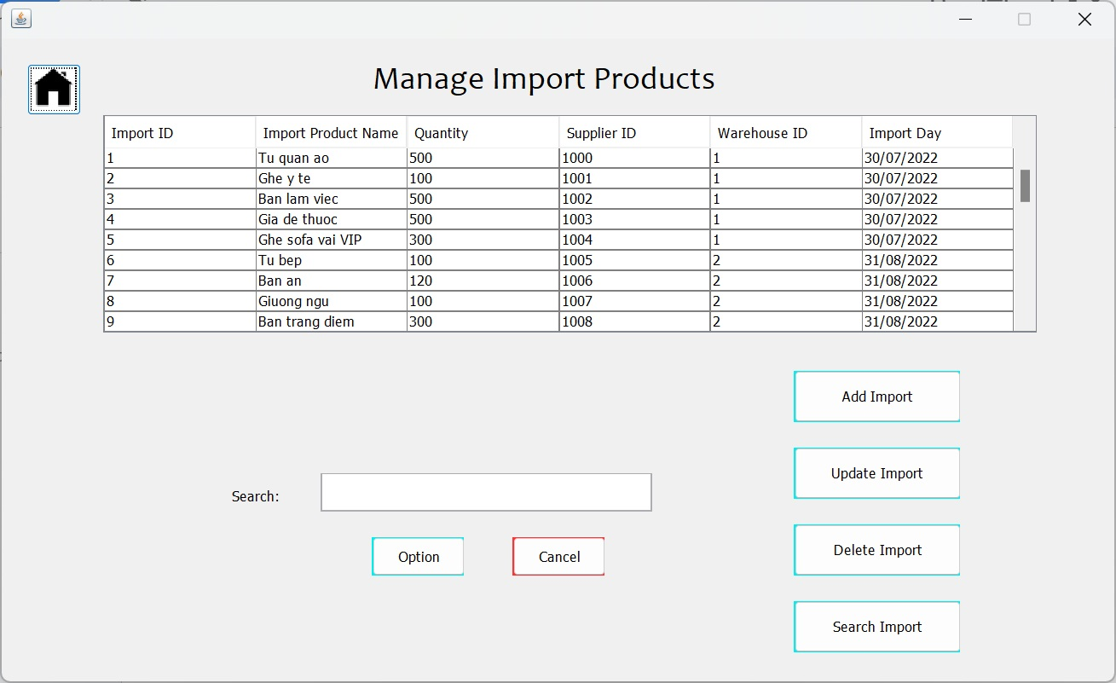

1. Process Name: View Supplier

Process Description and Details:

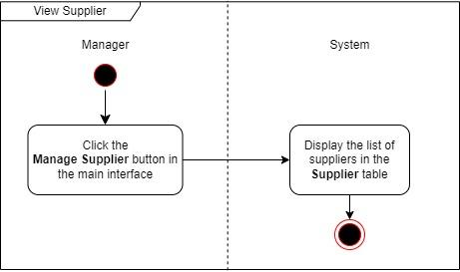

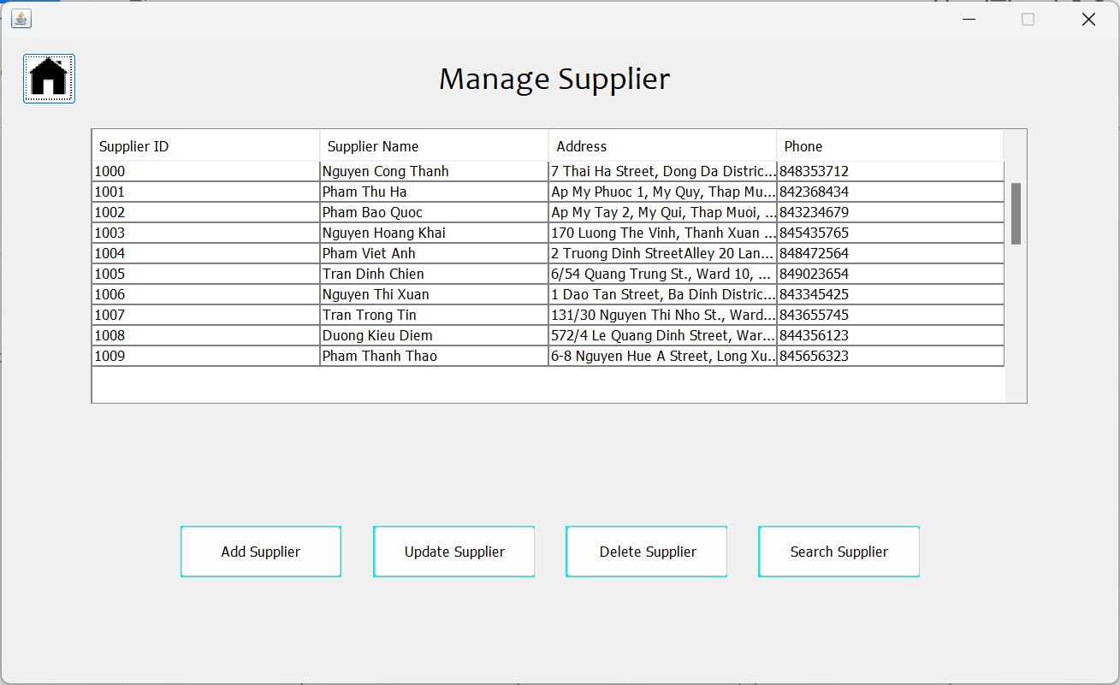

1. Process Name: Add new Supplier

Process Description and Details:

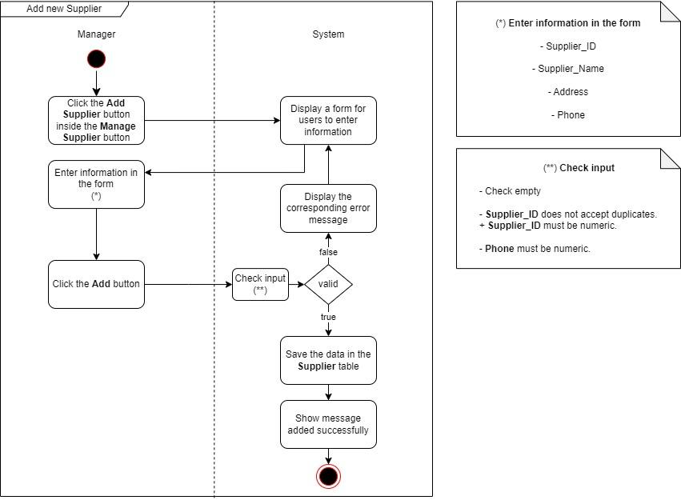

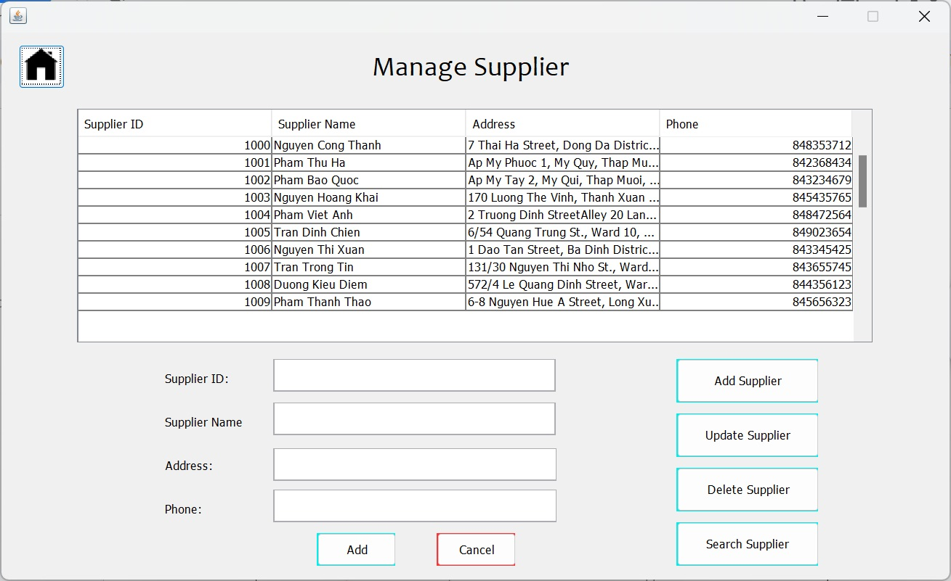

1. Process Name: Update Supplier

Process Description and Details:

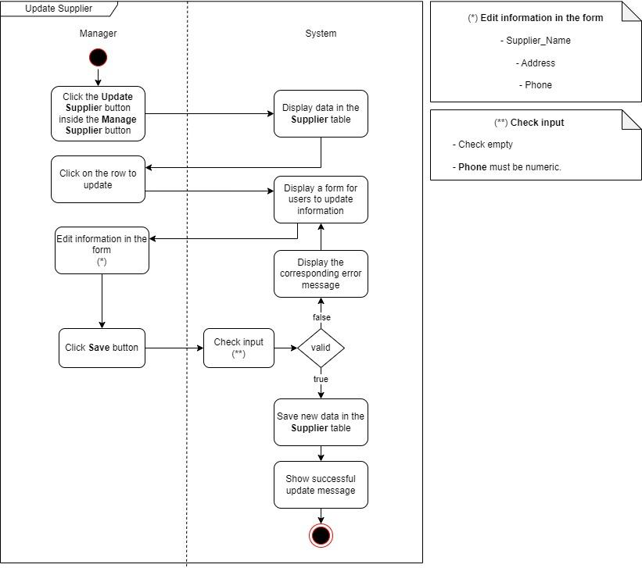

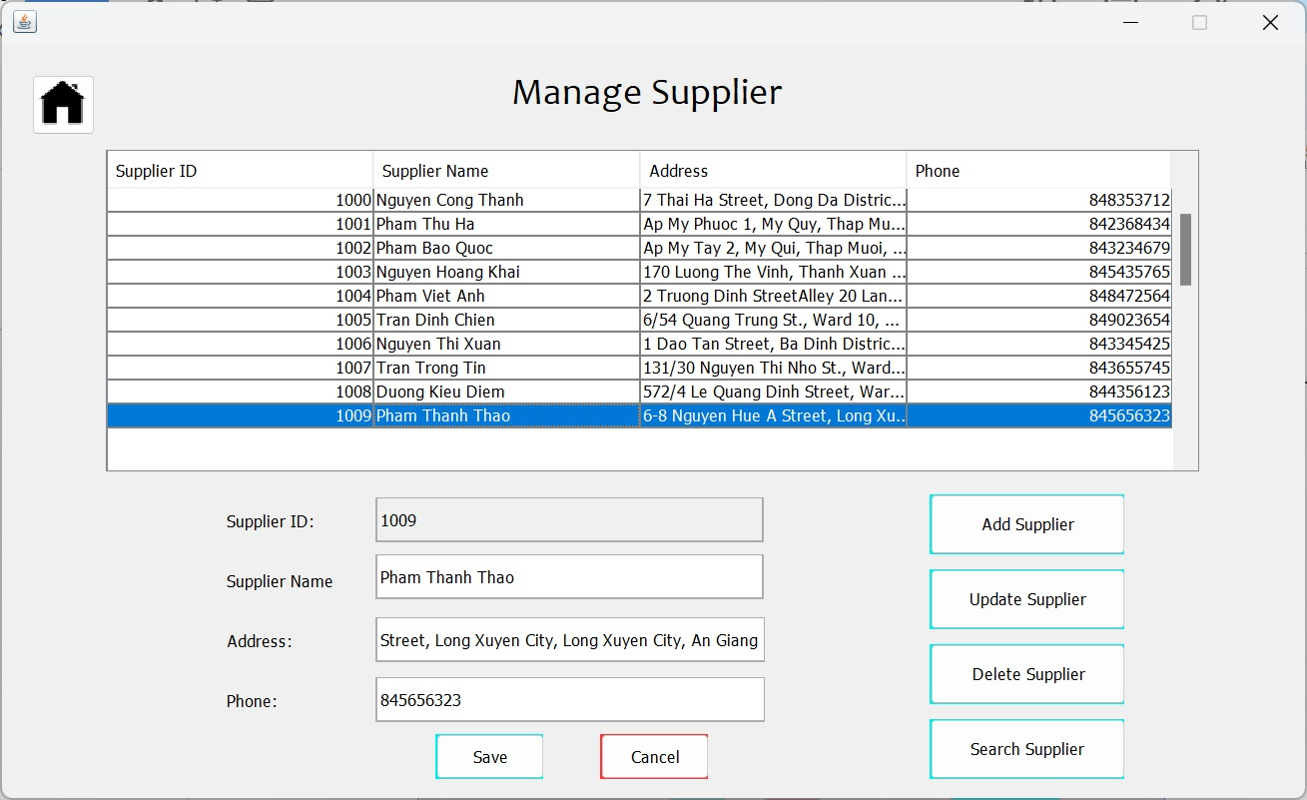

1. Process Name: Delete Supplier

Process Description and Details:

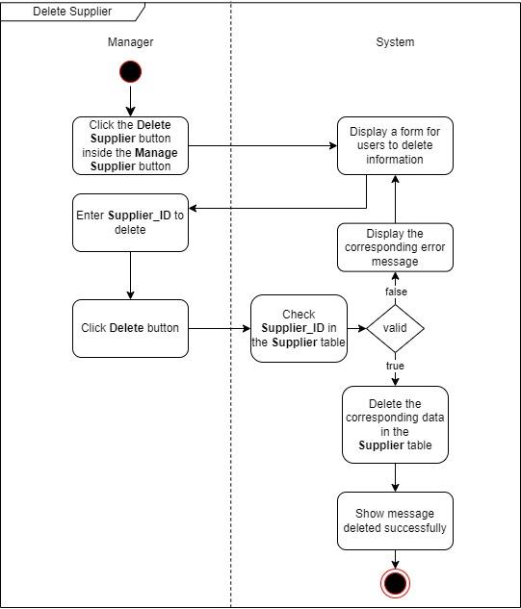

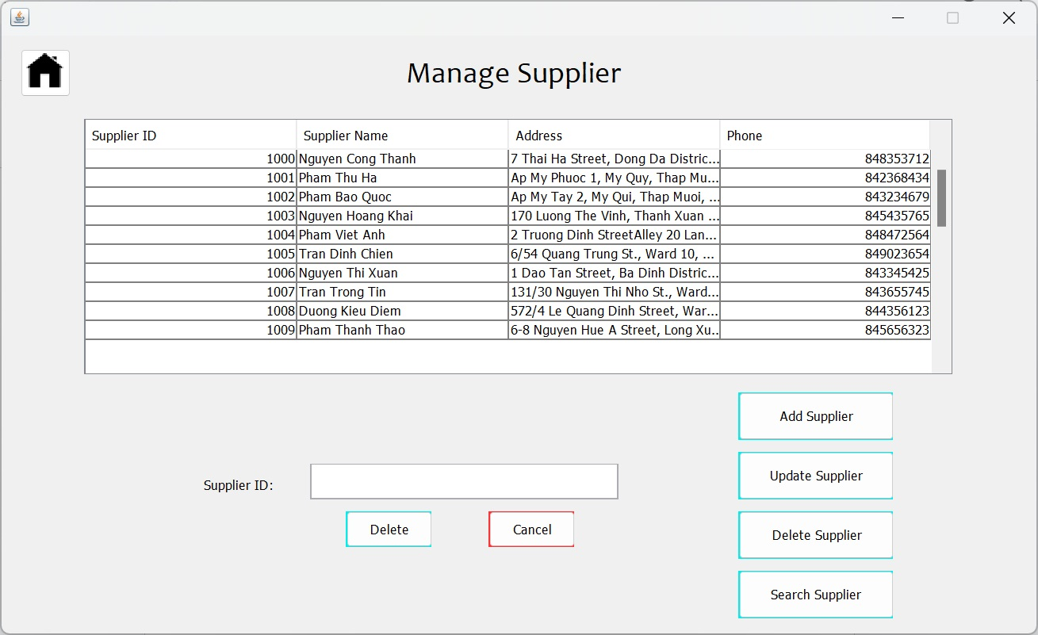

1. Process Name: Search Supplier

Process Description and Details:

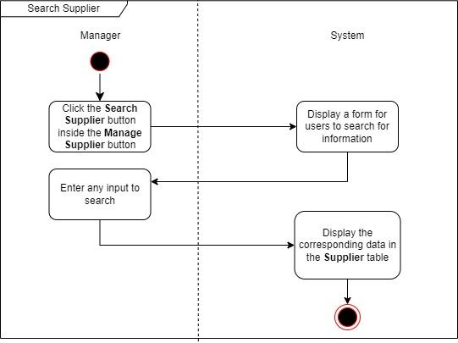

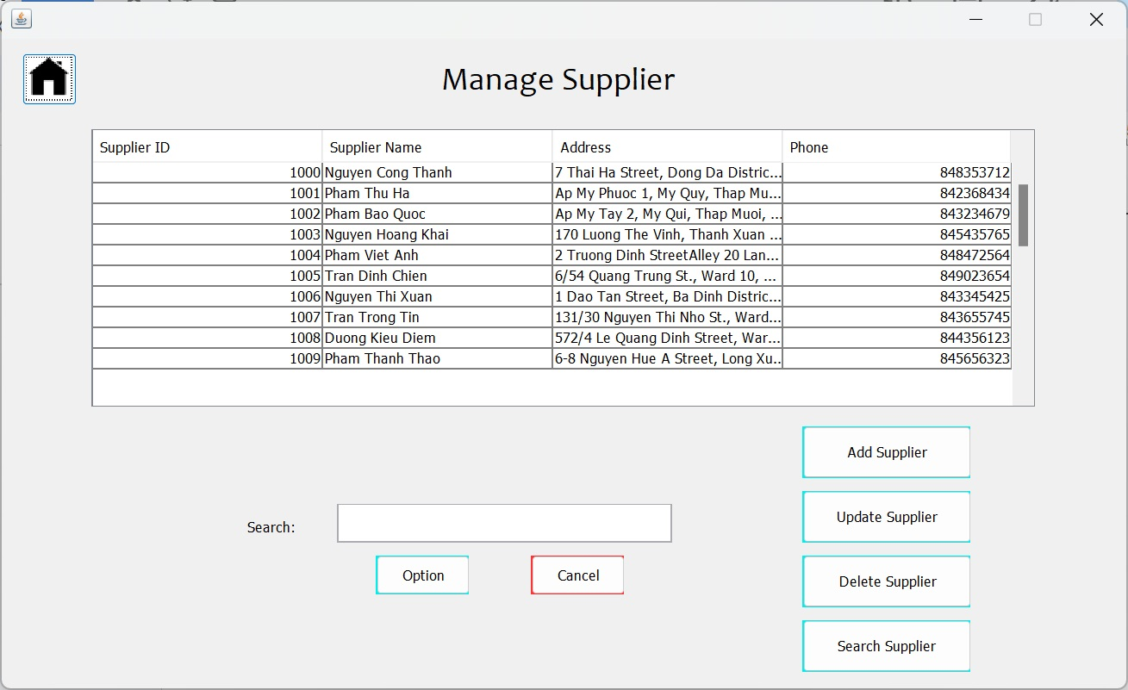

1. Process Name: View Warehouse

Process Description and Details:

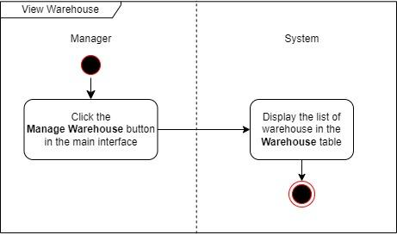

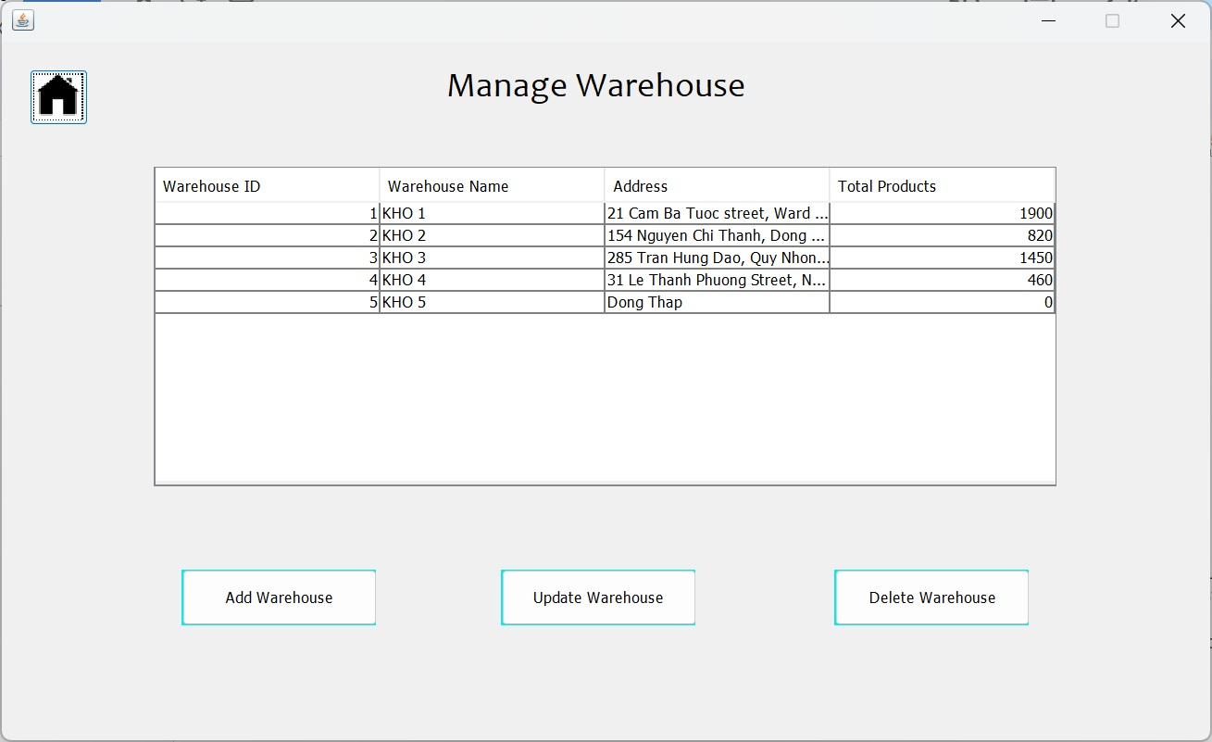

1. Process Name: Add Warehouse

Process Description and Details:

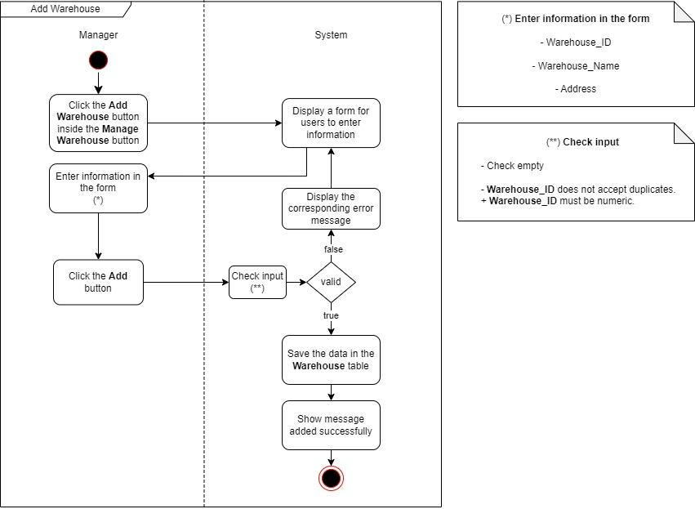

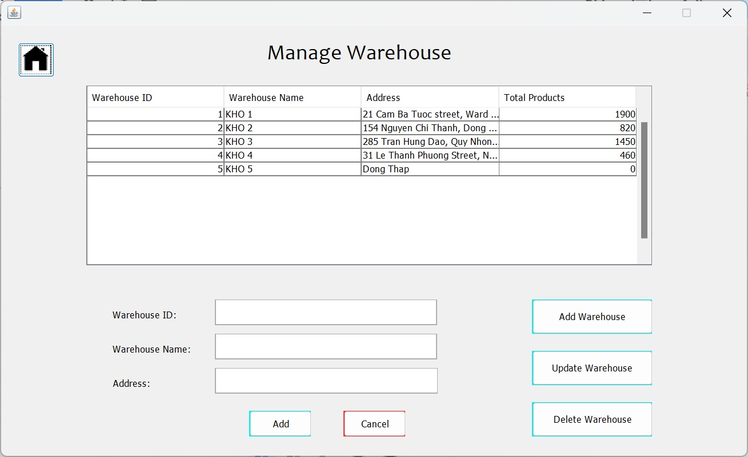

1. Process Name: Update Warehouse

Process Description and Details:

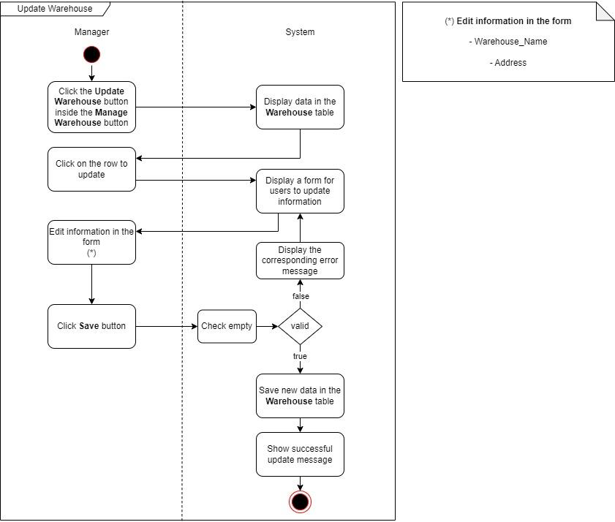

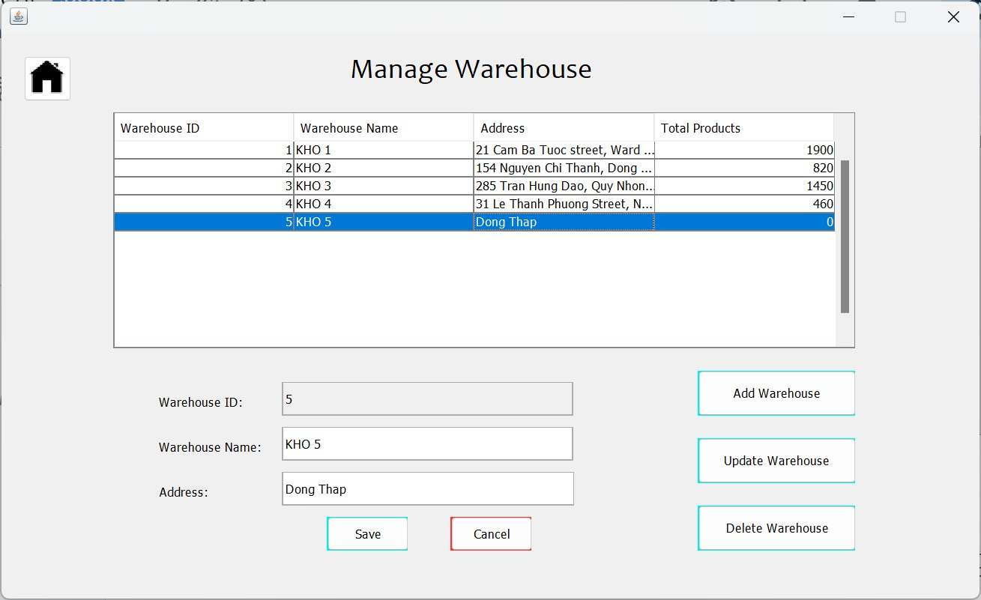

1. Process Name: Delete Warehouse

Process Description and Details:

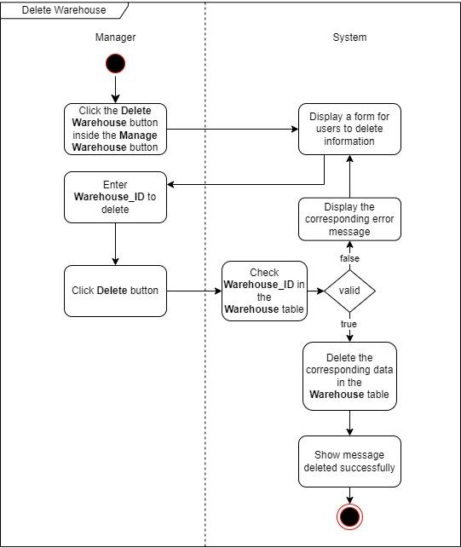

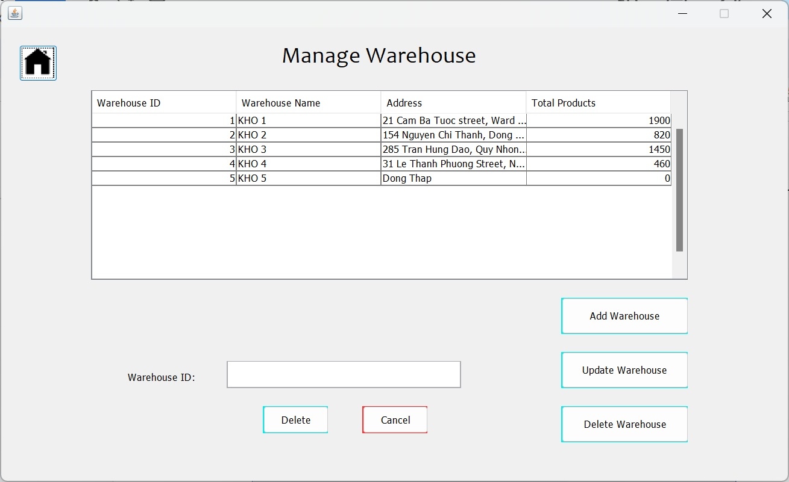

1. Process Name: View Categories

Process Description and Details:



1. Process Name: Add new Categories

Process Description and Details:

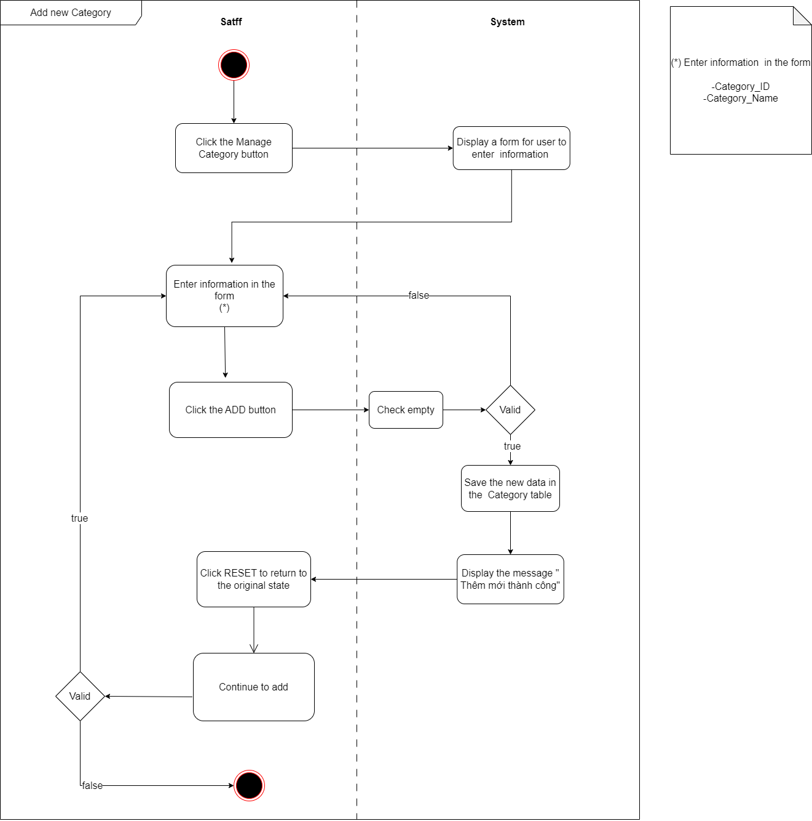\

1. Process Name: Update Categories

Process Description and Details:

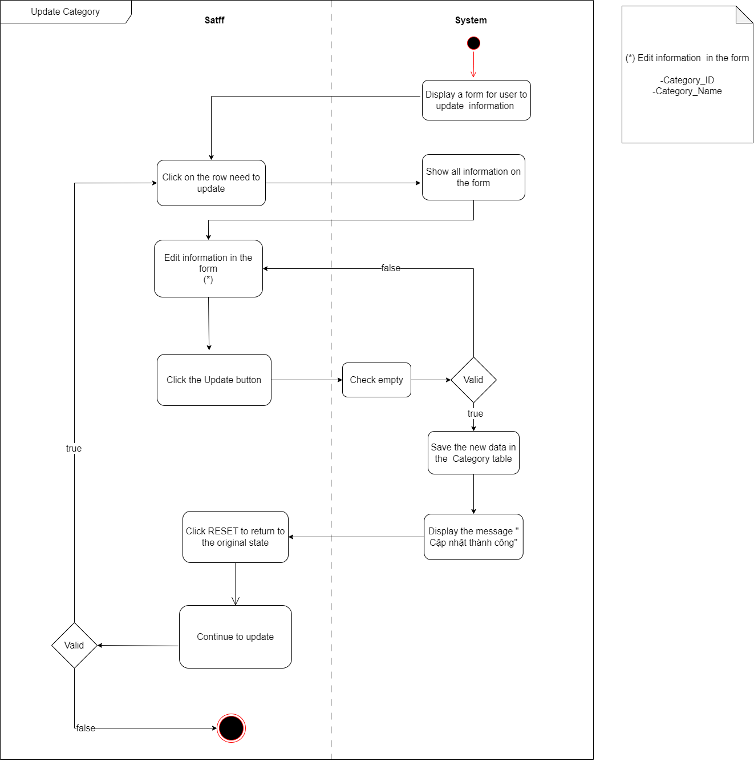

1. Process Name: Delete Categories

Process Description and Details:

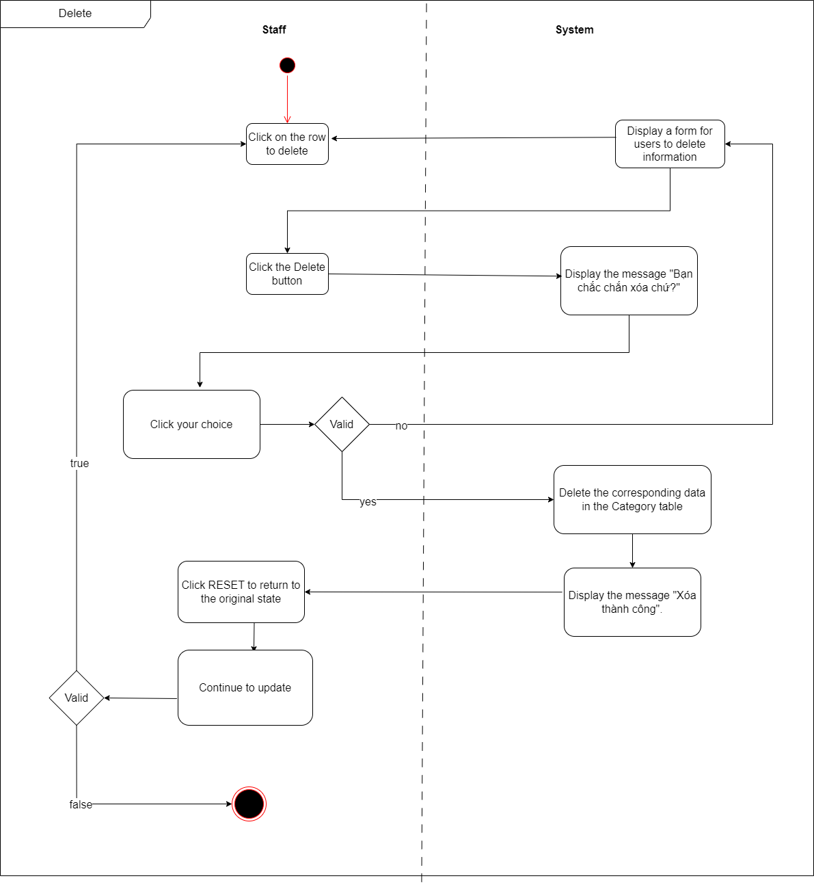

1. Process Name: View Product

Process Description and Details:



1. Process Name: Add new Product

Process Description and Details:

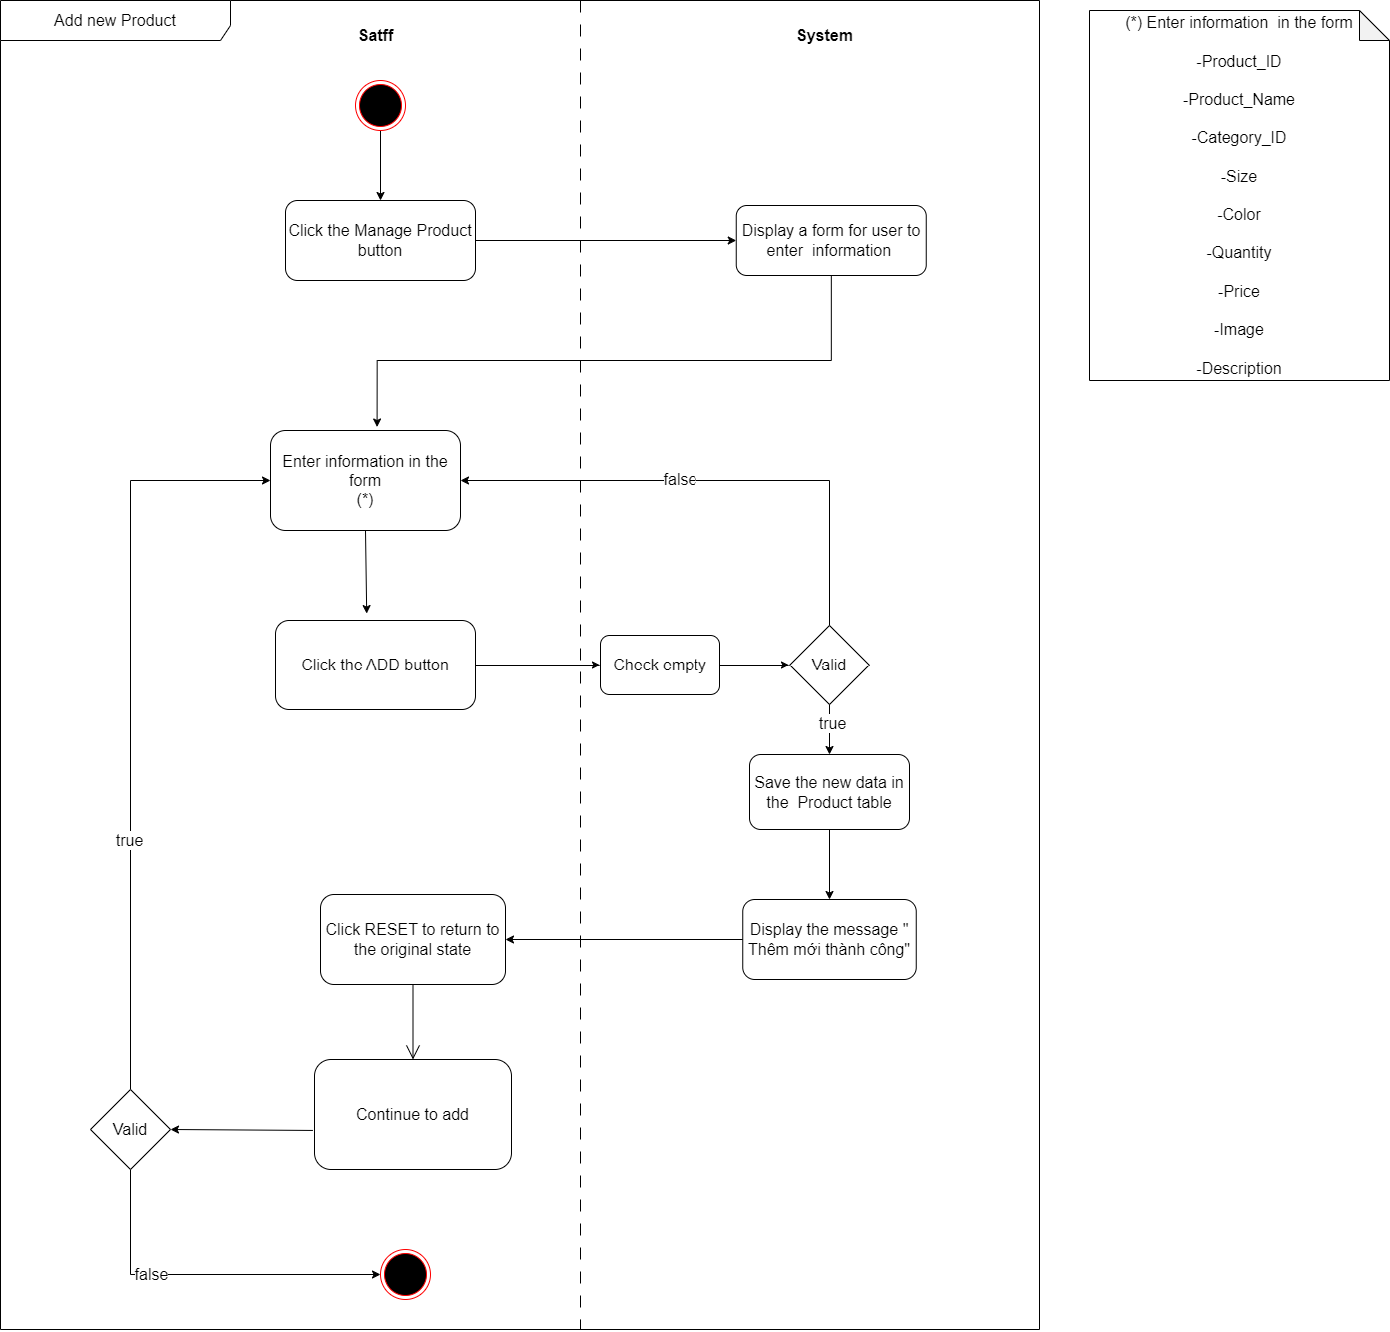

1. Process Name: Update Product

Process Description and Details:

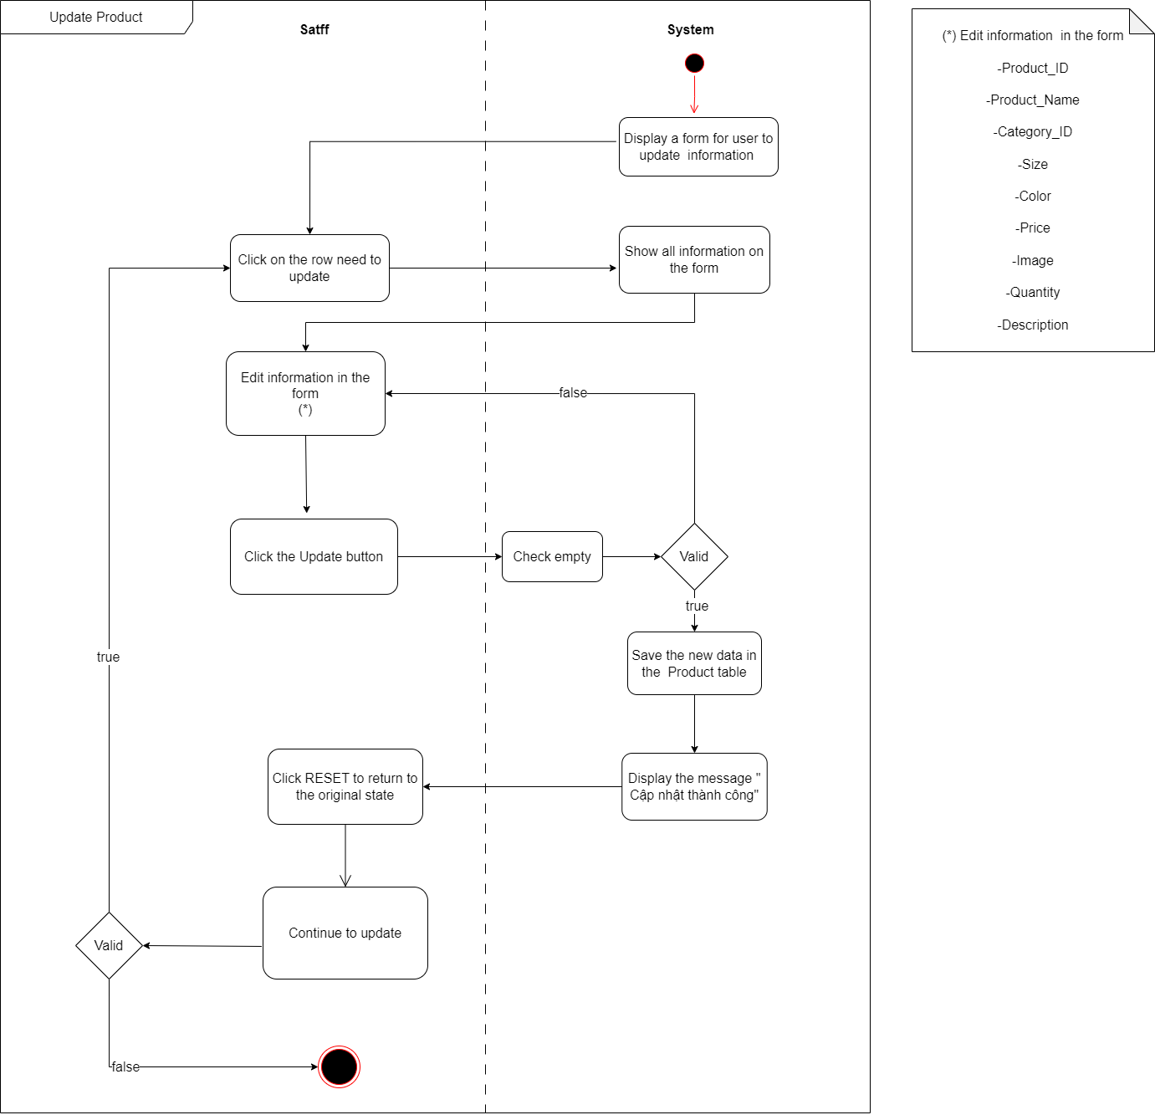

1. Process Name: Delete Product

Process Description and Details:

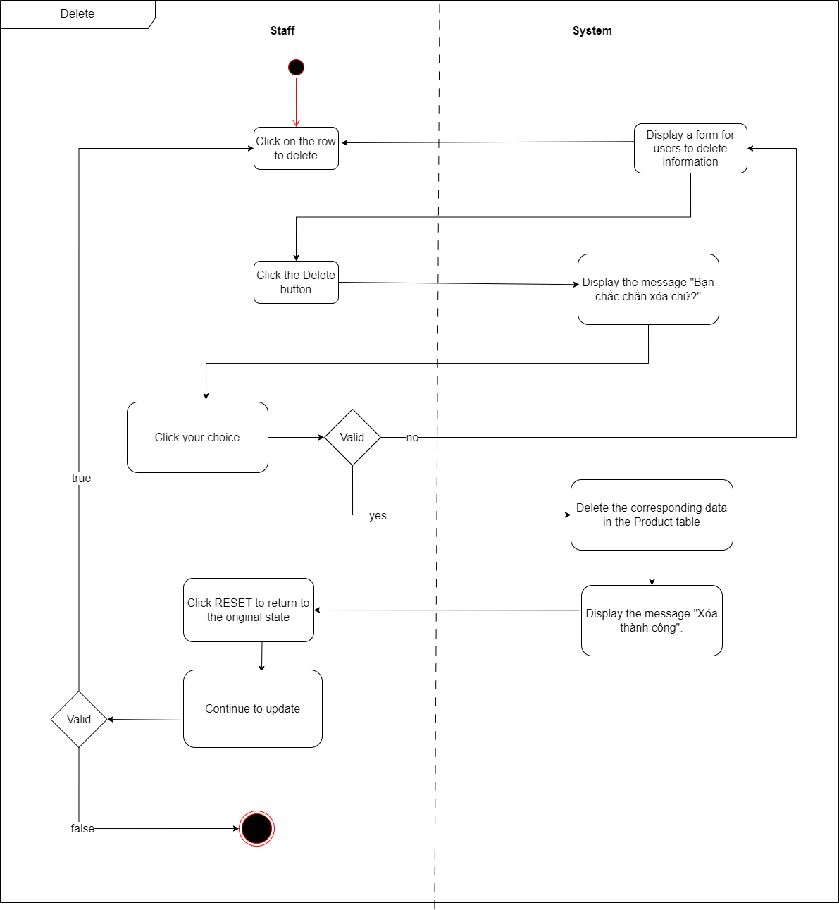

1. Process Name: Search Product

Process Description and Details:

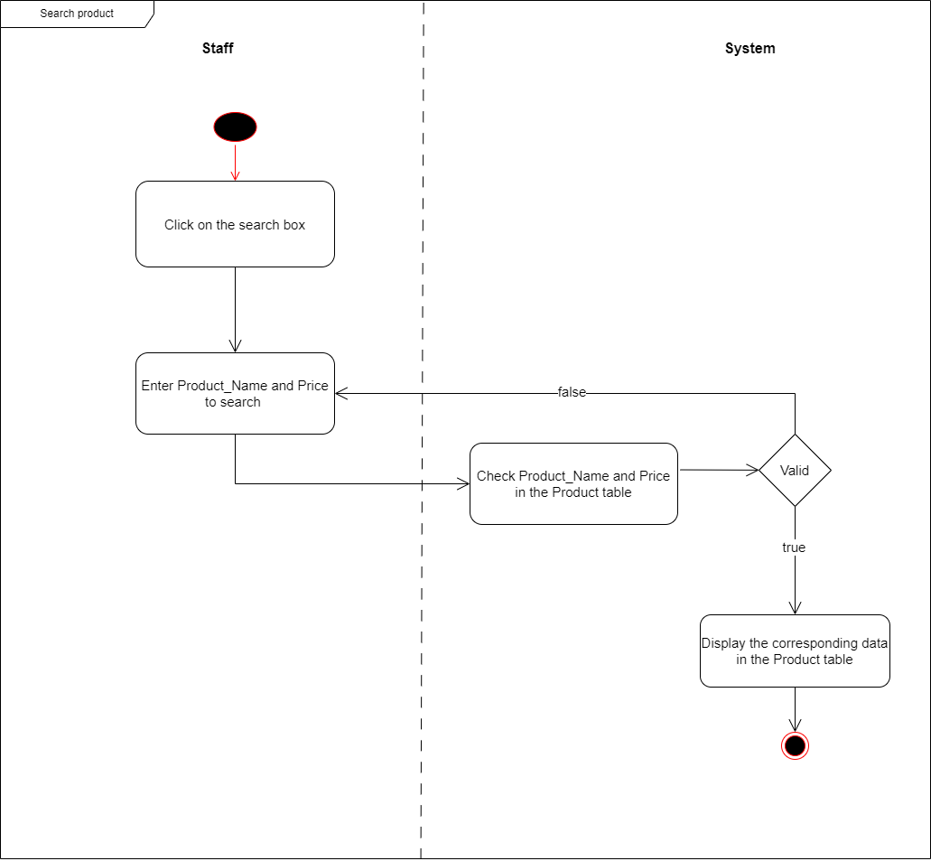

1. Process Name: View Promotion

Process Description and Details:

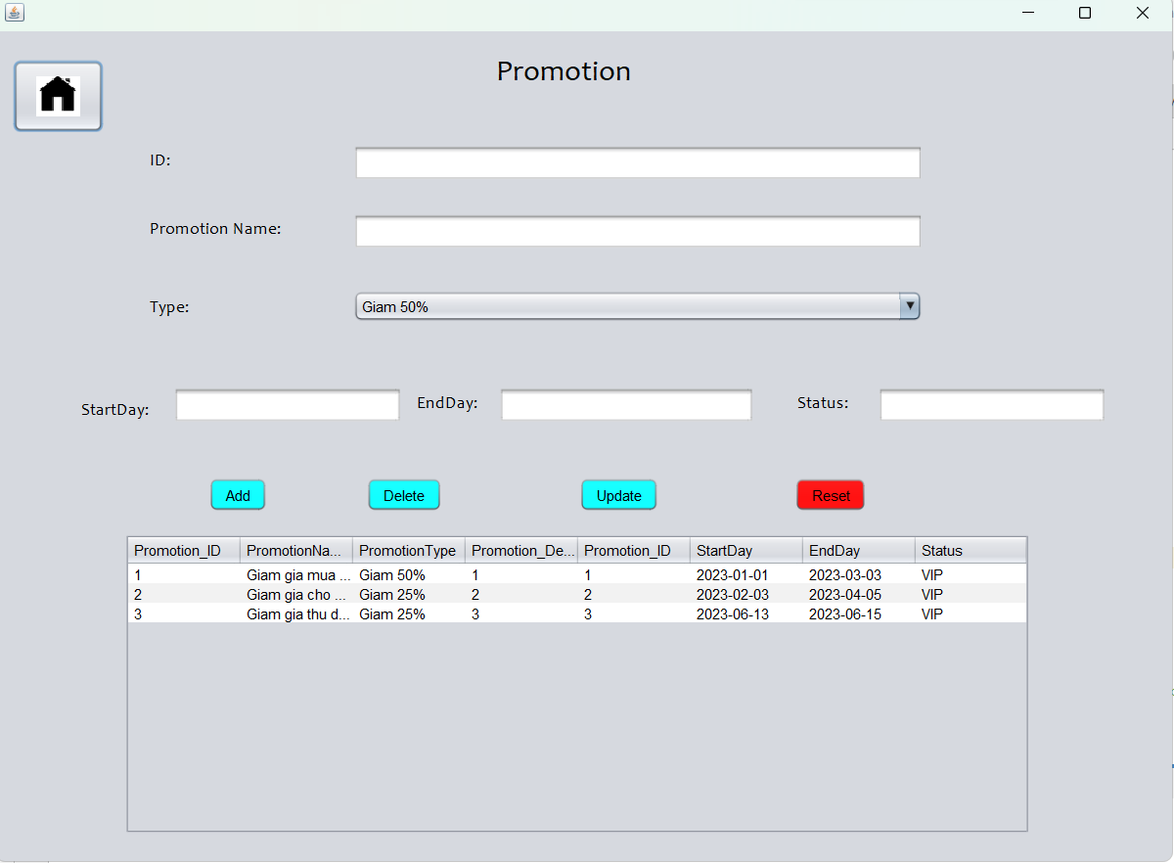

1. Process Name: Add new Promotion

Process Description and Details:

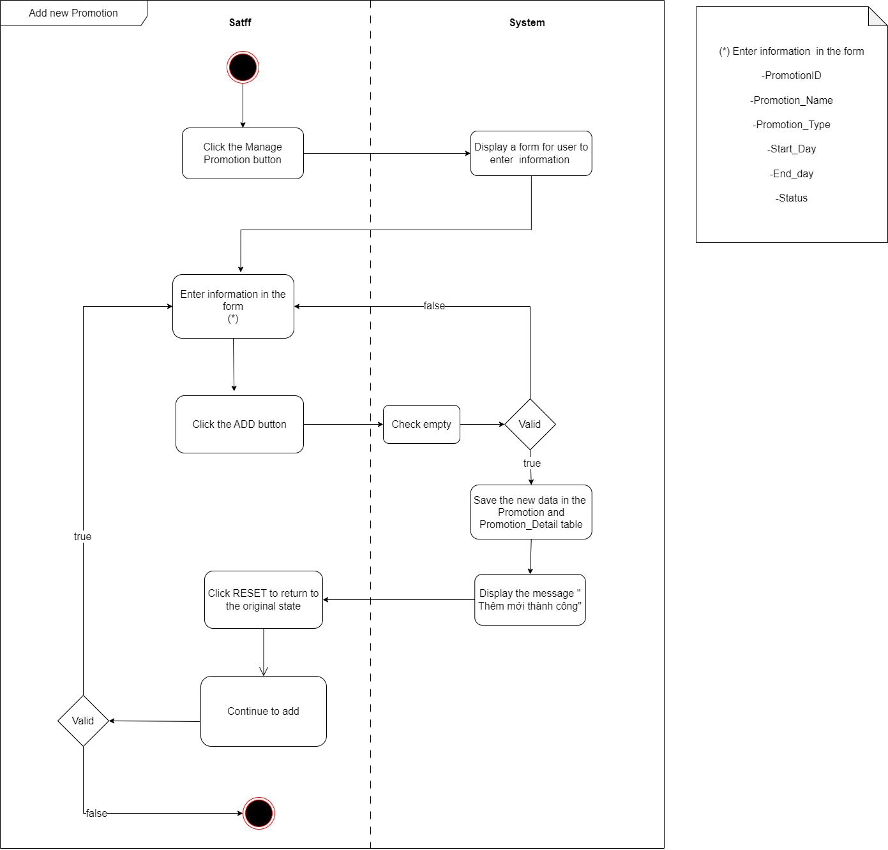

1. Process Name: Update Promotion

Process Description and Details:

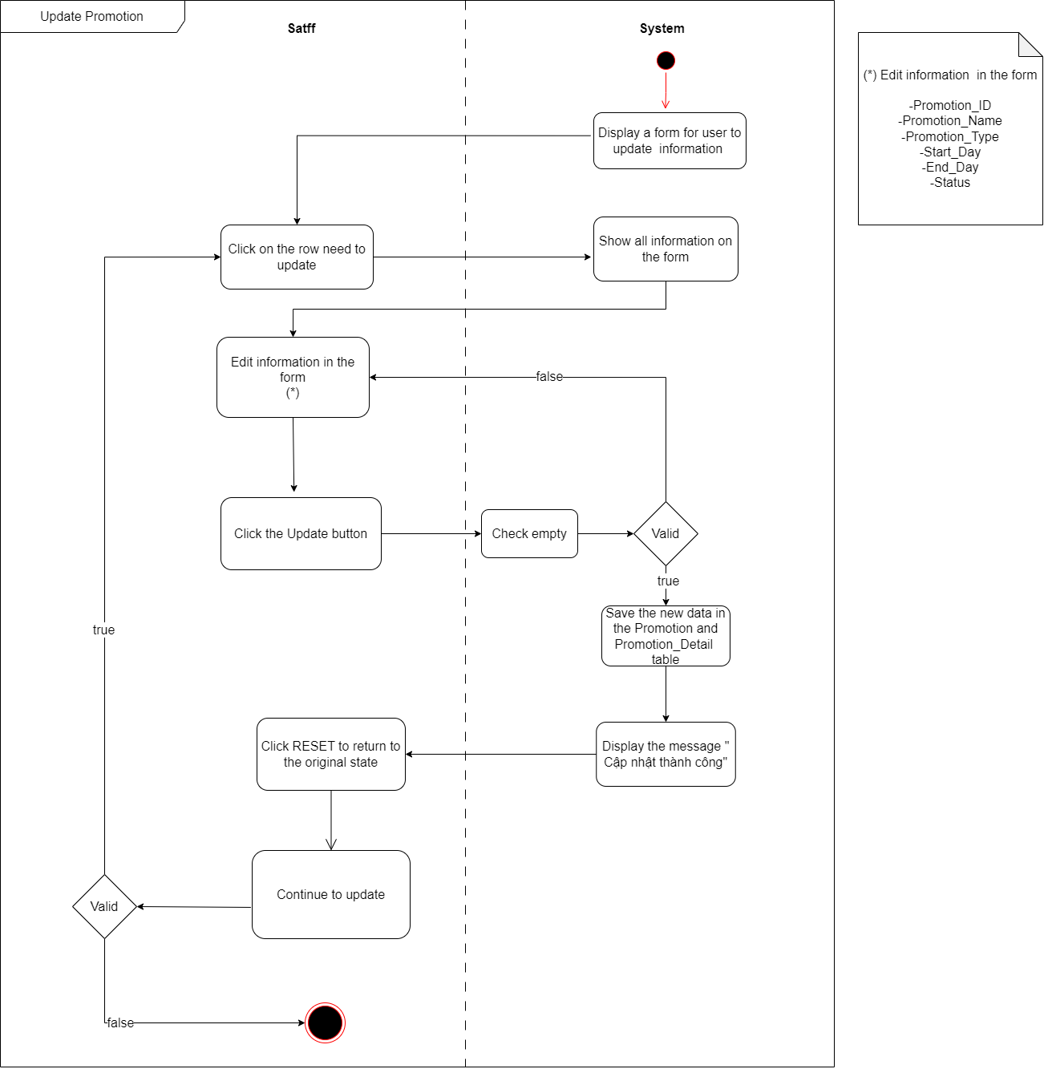

1. Process Name: Delete Promotion

Process Description and Details:

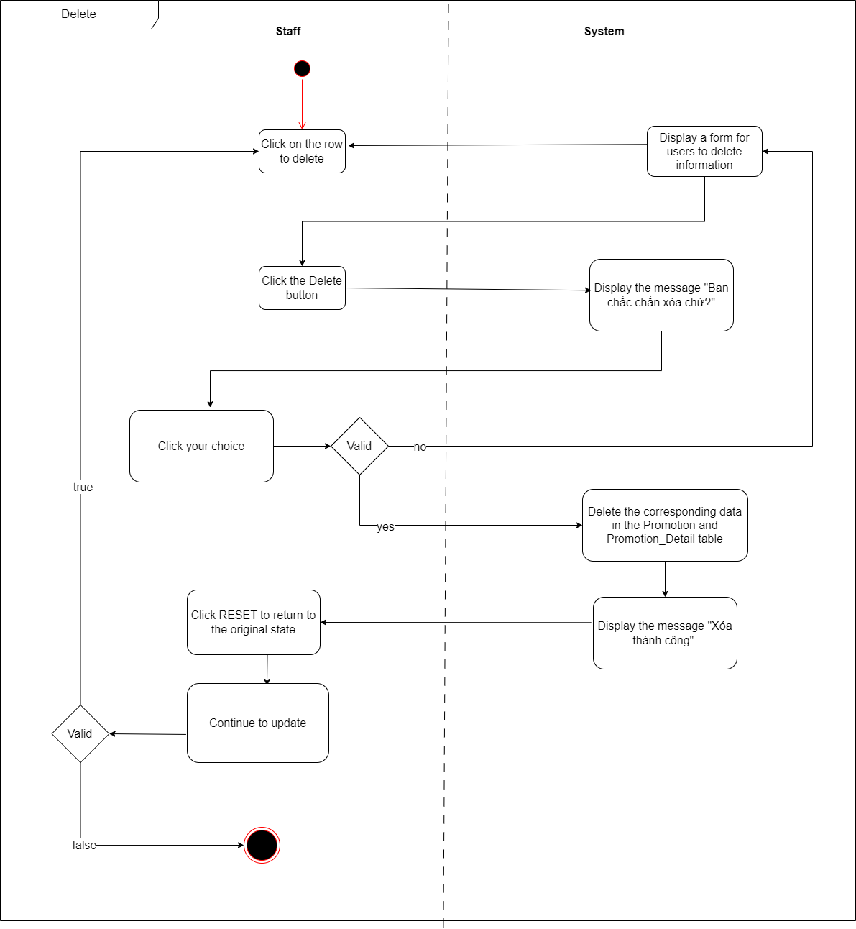

1. Process Name: View Debt

Process Description and Details:

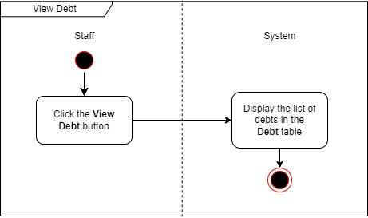

1. Process Name: Add new Debt

Process Description and Details:

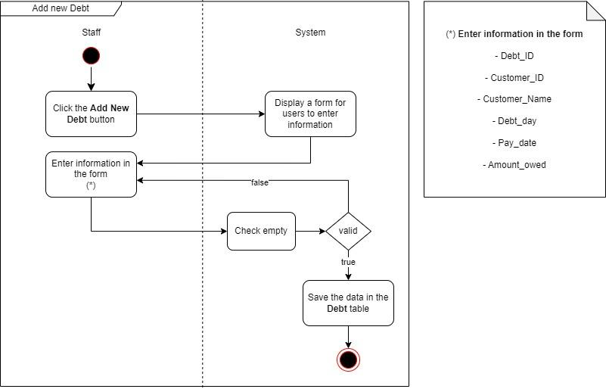

1. Process Name: Update Debt

Process Description and Details:

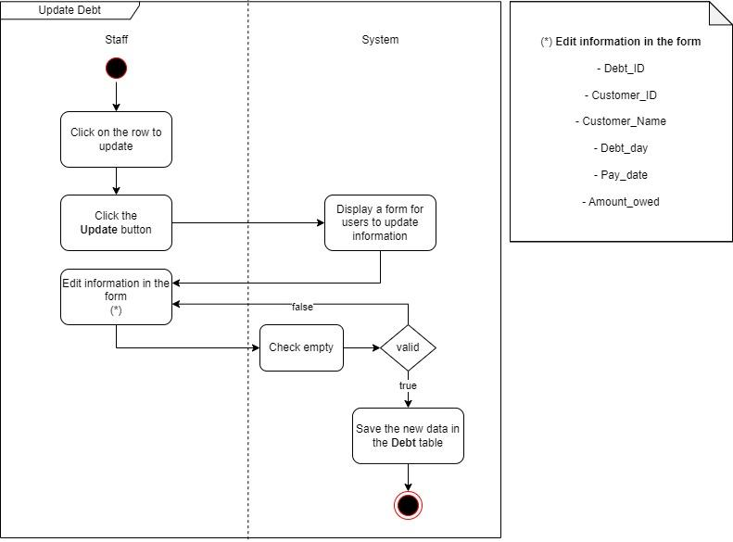

1. Process Name: Delete Debt

Process Description and Details:

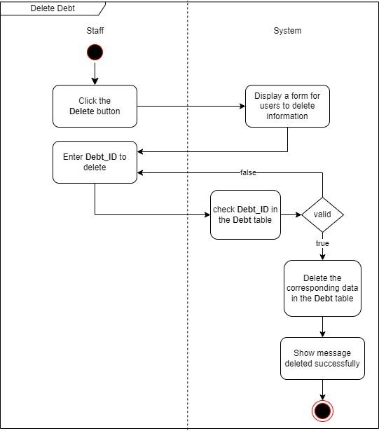

1. Process Name: View Order

Process Description and Details:

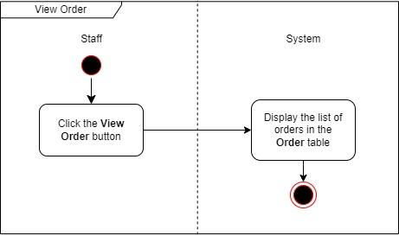

1. Process Name: Add new Order

Process Description and Details:

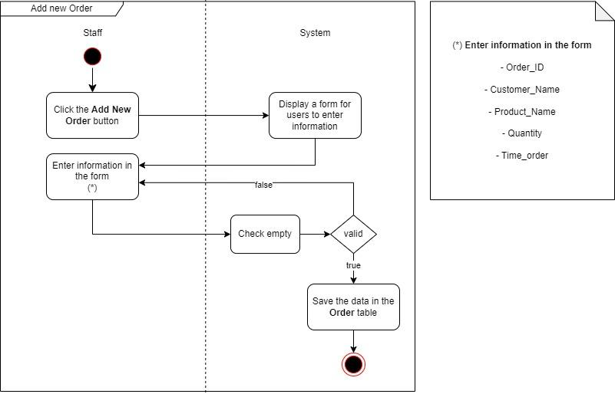

1. Process Name: Update Order

Process Description and Details:

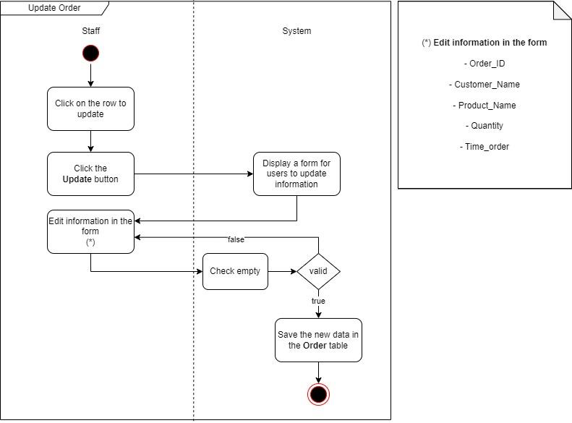

1. Process Name: Delete Order

Process Description and Details:

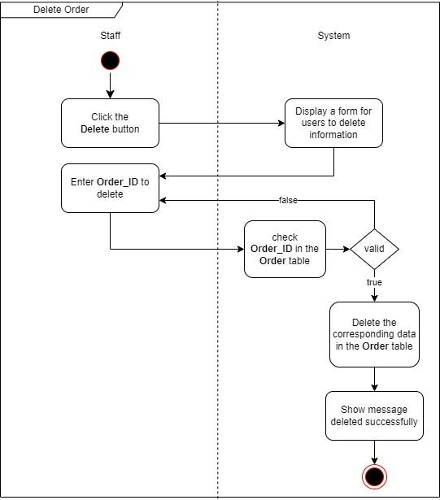

1. Process Name: Search Order

Process Description and Details:

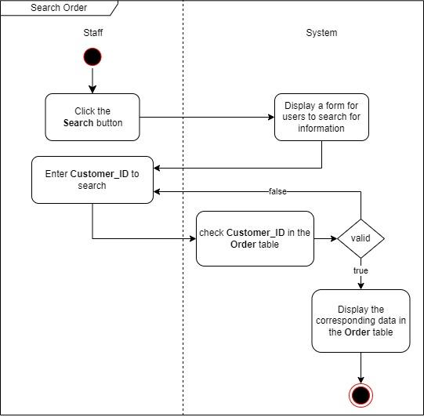

**CODING STANDARDS DOCUMENT**

1. **Programming Standards**

- Standard set name

- Standard code format

- Standard exception handling

- Standard used memory

- Standard handle string

- Standard use of static methods

- Standard set variable name

- Standard use of footnotes

1. **Standards for code writing style**

- Name variables, methods, classes, packages, according to CamelCase rules, where the first word is lowercase and the next words are capitalized. Example: firstName, getFirstName()

- Use spaces properly to make code easier to read, e.g. after keywords (if, else, for, while, switch), before and after commas, between operators (e.g. +, -, *, /), and between method parameters.

- Indent properly to show the structure of the program, making the source code easier to read. Usually use 4 spaces for indentation.

- Use the getter and setter methods to access and change the properties of the object, and name these methods according to the get/set +NameProperty rules, e.g. getFirstName(), setLastName().

- Using try-catch to handle exceptions in the program, and placing try-catch blocks in a correct structure makes the program easy to read and understand.

- Use the correct data type corresponding to the value and purpose of the variable.

**III.Standards for declaring Variables**

* Declare multiple variables of the same data type in the same line by separating them with commas. For example: int x, y, z.
* Name variables according to CamelCase rules, where the first word is lowercase and the next words capitalize the first letter. For example: firstName, lastName, numberOfStudents.
* Use a data type that matches the value and intended use of the variable. Avoid using data types that are too large or too small for your needs.
* Declare the variable in the form "NameDataTypeVariable name". For example: int age, String name, double salary

**IV.** Standards for Function Declarations

* Use variables for the right purposes
* Use parameters to pass data to the function and return the result using the "return" keyword. For example: public double calculateSalary(double baseSalary, double bonus), public String getFullName(String firstName, String lastName), public void setAge(int age).
* Use the return data type that matches the function's return result. If no result is returned, use data type "void".
* Place parentheses or braces in a new line, to make the source code easier to read.

**V.Other Standards**

* Use abstract classes and interfaces to separate parts of your program and define common methods.
* Use static methods to define common methods and minimize the creation of multiple objects.
* Using unit tests to check the functionality of the program and ensure the stability of the program.

**TASK SHEET**

1. Project Title: Furniture System

| **No.** | **Task** | **Actual Start Date** | **Actual Days** | **Teammate Name** | **Status** |
| --- | --- | --- | --- | --- | --- |
|  | Document: 1 | 14/05/2023 | 7 days | Nguyen Ngoc Bao Thi | Completed |
|  | Document: 2 | 15/05/2023 | 7 days | Pham Bao Quoc | Completed |
|  | Document: 3 | 22/05/2023 | 11 days | Pham Bao Quoc | Completed |
|  | Document: 4 | 23/05/2023 | 2 days | Nguyen Minh Tri Duc | Completed |
|  | Document: 5 | 24/05/2023 | 14 days | Nguyen Minh Tri Duc | Completed |
|  | Document: 6 | 23/05/2023 | 10 days | Nguyen Ngoc Bao Thi | Completed |
|  | Document: 7 | 24/05/2023 | 7 days | Pham Bao Quoc | Completed |
|  | Document: 8 | 30/05/2023 | 5 days | Nguyen Duong Kieu Diem Quynh | Completed |
|  | Document: 9 | 30/05/2023 | 7 days | Nguyen Duong Kieu Diem Quynh | Completed |
|  | Document: 10 | 08/06/2023 | 1 day | Nguyen Ngoc Bao Thi | Completed |
|  | Document: 11 | 01/06/2023 | 4 days | Nguyen Minh Tri Duc | Completed |
|  | Document: 12 | 04/06/2023 | 2 days | Nguyen Duong Kieu Diem Quynh | Completed |
| 13 | Demo:Manage records (Customers/Employees) (login, register, add, edit, delete customer and employee information, change password, ...)  -Manage feedback for the entire application (customer feedback information, feedback content) | 25/05/2023 | 26 days | Nguyen Duong Kieu Diem Quynh | Completed |
| 14 | Demo:- Warehouse management (display, update products in stock, quantity in stock).  - Supplier management (name of supplier, quantity of products supplied per month, ).  -Manage, import goods (time of export, import, quantity of imported goods). | 25/05/2023 | 17 days | Pham Bao Quoc | Completed |
| 15 | Demo:-Product management (search for more, edit and delete products, product statistics, manage product details (product description, size, color, ...)).  - Manage categories (search, add, edit, delete categories).  -Promotion management (Promo code, promotion name, promotion type, start date, end date, status (all products). | 26/05/2023 | 20 days | Nguyen Ngoc Bao Thi | Completed |
| 16 | Demo:Customers purchase, pay, view order history.  -Sales management (displaying products, selling products, ... statistics of total revenue by each product) - staff / management staff.  - Order management - staff.  - Manage customer debt (installment management, how much installment payment, paid amount, outstanding amount, period of periodic payment, ..). | 26/05/2023 |  | Nguyen Minh Tri Duc | Incomplete |

**TESTING DOCUMENT**

| **ID** | **Test Case Name** | **Task** | **Result** | |
| --- | --- | --- | --- | --- |
| **Expected** | **Actual Result**  Pass/Fail-Comments |
|  | Add Staff | Enter Staff 1:  Staff_ID: A100  Staff_Name: Nguyen Van Hieu  Address: Hau Giang  Phone:0865792456  Email: [nvhieu@gmail.com](mailto:nvhieu@gmail.com)  Salary: 5000000  Username: nvhieu123  Password: 123 | Record is added to the database | Pass |
| Enter Staff 2:  Staff_ID: A101  Staff_Name: Le Nguyen  Address: Can Tho  Phone:0845761254  Email: lnguyen@gmail.com  Salary: 6500000  Username: lnguyen123  Password: 123 |
| Enter Staff 3:  Staff_ID: A102  Staff_Name: Ly Khoi  Address: Vinh Long  Phone:0845761254  Email: lkhoi@gmail.com  Salary: 5500000  Username: lkhoi123  Password: 123 |
| Enter Staff 4:  Staff_ID: A103  Staff_Name: Nguyen Thi Ngoc  Address: Soc Trang  Phone:0854761854  Email: ntngoc@gmail.com  Salary: 5500000  Username: ntngoc123  Password: 123 |
| Enter Staff 5:  Staff_ID: A104  Staff_Name: Le Minh Chau  Address: Ca Mau  Phone:0335749864  Email:lmchau@gmail.com  Salary: 5000000  Username: lmchau123  Password: 123 |
| Enter Staff 6 :  Staff_ID: A105  Staff_Name: Dinh My Thanh  Address: Hue  Phone:0354658732  Email:dmthanh@gmail.com  Salary: 6000000  Username:dmthanh123  Password: 123 |
| Enter Staff 7:  Staff_ID: A106  Staff_Name: Tran Pham Buu Khoa  Address: Ha Noi  Phone:0325465482  Email:tpbkhoa@gmail.com  Salary: 7500000  Username:tpbkhoa123  Password: 123 |
| Enter Staff 8:  Staff_ID: A107  Staff_Name: Pham My Linh  Address: TP.HCM  Phone:0972462586  Email: pmlinh@gmail.com  Salary: 6000000  Username: pmlinh123  Password: 123 |
| Enter Staff 9:  Staff_ID: A108  Staff_Name: Tran Van Khang  Address: Vinh Phuc  Phone:0336486458  Email:tvkhang@gmail.com  Salary: 6000000  Username: tvkhang123  Password: 123 |
| Enter Staff 10:  Staff_ID: A109  Staff_Name: Ly Ngoc Ngan  Address: Kien Giang  Phone:0359468547  Email: lnngan@gmail.com  Salary: 7000000  Username:lnngan123  Password: 123 |
|  | Add Product | Product_ID:1  Product_Name: Tu quan ao  Category_ID: 1  Price: 500000  Quantity:500  Color: White  Size: Lon  Image: tuquanao.jpg  Description: Danh cho nha o | Record is added to the database  . | Pass |
| Product_ID:2  Product_Name: Ke sach  Category_ID: 3  Price: 300000  Quantity:200  Color: White  Size: Vua  Image: ke_sach.jpg  Description: Su dung cho truong hoc, thu vien |
| Product_ID:3  Product_Name: Ban lam viec  Category_ID: 2  Price: 600000  Quantity:499  Color: White  Size: Vua  Image: banlamviec.jpg  Description:Danh cho van phong, cong ty |
| Product_ID:4  Product_Name: Gia de thuoc  Category_ID: 4  Price: 300000  Quantity:500  Color: White  Size: Vua  Image: giadethuoc.jpg  Description: Danh cho benh vien, nha thuoc |
| Product_ID:5  Product_Name: Ghe sofa vai cao cap  Category_ID: 1  Price: 9000000  Quantity:300  Color: Grey  Size: Lon  Image: sofa.jpg  Description: Danh cho nha o |
| Product_ID:6  Product_Name: Tu bep  Category_ID: 1  Price: 3200000  Quantity:100  Color: Brown  Size: Vua  Image: tubep.jpg  Description: Danh cho nha bep |
| Product_ID:7  Product_Name: Ban an  Category_ID: 1  Price: 3300000  Quantity:120  Color: Grey  Size: Vua  Image: banan.jpg  Description: Danh cho nha bep |
| Product_ID:8  Product_Name: Giuong ngu  Category_ID: 1  Price: 9000000  Quantity:100  Color: White  Size: Lon  Image: Giuongngu.jpg  Description: Danh cho phong ngu |
| Product_ID:9  Product_Name: Ban trang diem  Category_ID: 1  Price: 2100000  Quantity:300  Color: White  Size: Vua  Image: bantrangdiem.jpg  Description: Danh cho phong ngu |
| Product_ID:10  Product_Name: Ban hop  Category_ID: 2  Price: 3000000  Quantity:200  Color: Brown  Size: Lon  Image: banhop.jpg  Description: Danh cho van phong |
| Product_ID:11  Product_Name: Tu tai lieu  Category_ID: 2  Price: 1500000  Quantity:150  Color: Grey  Size: Lon  Image: tutailieu.jpg  Description: Dung de tai lieu, hop dong |
| Product_ID:12  Product_Name: Ghe van phong  Category_ID: 2  Price: 2000000  Quantity:300  Color: Black  Size: Vua  Image:ghelamviec.jpg  Description: Danh cho nhan vien |
| Product_ID:13  Product_Name: Ban giam doc  Category_ID: 2  Price: 5000000  Quantity:300  Color: Black  Size: Vua  Image: bangiamdoc.jpg  Description: Sang trong |
| Product_ID:14  Product_Name: Ban ghe giao vien  Category_ID: 3  Price: 300000  Quantity:200  Color: Brown  Size: Vua  Image:banghegiaovien.jpg  Description: Danh cho giao vien |
| Product_ID:15  Product_Name: Ban ghe hoc sinh cap 1-2  Category_ID: 3  Price: 900000  Quantity:400  Color: White  Size: Vua  Image: ban_hs.jpg  Description: Danh cho hoc sinh cap1-2 |
| Product_ID:16  Product_Name: Giuong y te  Category_ID: 4  Price: 2100000  Quantity:500  Color: Grey  Size: Vua  Image:giuongyte.jpg  Description: Danh cho benh nhan |
| Product_ID:17  Product_Name: Ghe y te  Category_ID: 4  Price: 2000000  Quantity:100  Color: Grey  Size: Vua  Image: gheyte.jpg  Description: Danh cho benh vien |
| Product_ID:18  Product_Name: Tu y te ca nhan  Category_ID: 4  Price: 1600000  Quantity:70  Color: Grey  Size: Vua  Image: tuytecanhan.jpg  Description: Danh cho benh vien |
| Product_ID:19  Product_Name: Coc truyen y te  Category_ID: 4  Price: 350000  Quantity:190  Color: Grey  Size: Vua  Image: coctruyenyte.jpg  Description: Gia do truyen thuoc |
| Product_ID:20  Product_Name: Tu de do hoc sinh mau giao  Category_ID: 3  Price: 3200000  Quantity:200  Color: Blue  Size: Lon  Image: tudedohs.jpg  Description: Danh cho hoc sinh mau giao |
| 3. | Add Warehouse | Warehouse_ID: 1  Warehouse_Name: KHO 1  Address: 21 Cam Ba Tuoc street, Ward 7, Phu Nhuan District, Tp.HCM  Total_Products: 500 | Record is added to the database | Pass |
| Warehouse_ID:2  Warehouse_Name: KHO 2  Address: 154 Nguyen Chi Thanh, Dong Da District, Ha Noi  Total_Products: 500 |
| Warehouse_ID:3  Warehouse_Name: KHO 3  Address: 285 Tran Hung Dao, Quy Nhon City, Binh Dinh  Total_Products: 500 |
| Warehouse_ID:4  Warehouse_Name: KHO 4  Address: 31 Le Thanh Phuong Street, Nha Trang City, Khanh Hoa  Total_Products: 500 |
| 4. | Add Import Product Detail | Import_Detail_ID: 1  Import_ID:1  Warehouse_ID:1  Import_day:17/05/2022 | Record is added to the database | Pass |
| Import_Detail_ID:2  Import_ID:2  Warehouse_ID:2  Import_day:17/05/2022 |
| Import_Detail_ID:3  Import_ID:3  Warehouse_ID:3  Import_day:17/05/2022 |
| Import_Detail_ID:4  Import_ID:4  Warehouse_ID:4  Import_day:17/05/2022 |
| Import_Detail_ID:5  Import_ID:5  Warehouse_ID:1  Import_day:30/07/2022 |
| Import_Detail_ID:6  Import_ID:6  Warehouse_ID:2  Import_day:30/07/2022 |
| Import_Detail_ID:7  Import_ID:7  Warehouse_ID:3  Import_day:30/07/2022 |
| Import_Detail_ID:8  Import_ID:8  Warehouse_ID:4  Import_day:30/07/2022 |
| Import_Detail_ID:9  Import_ID:9  Warehouse_ID:1  Import_day:30/07/2022 |
| Import_Detail_ID:10  Import_ID:10  Warehouse_ID:2  Import_day:30/07/2022 |
| 5. | Add Import Product | Import_ID:1  Import_Product_Name: Tu quan ao  Quantity:500  Supplier_ID:1000 | Record is added to the database | Pass |
| Import_ID:2  Import_Product_Name:Ke sach  Quantity:200  Supplier_ID:1007 |
| Import_ID:3  Import_Product_Name:Ban lam viec  Quantity:500  Supplier_ID:1004 |
| Import_ID:4  Import_Product_Name:Ghe sofa cao cap  Quantity:300  Supplier_ID:1005 |
| Import_ID:5  Import_Product_Name:Giuong ngu  Quantity:100  Supplier_ID:1006 |
| Import_ID:6  Import_Product_Name: Bang treo tuong  Quantity:300  Supplier_ID:1007 |
| Import_ID:7  Import_Product_Name:Ban may tinh  Quantity:200  Supplier_ID:1008 |
| Import_ID:8  Import_Product_Name:Ghe van phong  Quantity:300  Supplier_ID:1009 |
| Import_ID:9  Import_Product_Name:Giuong y te  Quantity:500  Supplier_ID:1004 |
| Import_ID:10  Import_Product_Name: Ban trang diem  Quantity:300  Supplier_ID:1001 |
| 6. | Add Supplier | Supplier_ID:1000  Supplier_Name:Nguyen Cong Thanh  Address:7 Thai Ha Street, Dong Da District, Ha Noi.  Phone:0848353712 | Record is added to the database | Pass |
| Supplier_ID:1001  Supplier_Name:Pham Thu Ha  Address:Dong Thap  Phone:0842368434 |
| Supplier_ID:1002  Supplier_Name:Pham Bao Quoc  Address:Dong Thap  Phone:0843234675 |
| Supplier_ID:1003  Supplier_Name:Nguyen Hoang Khai  Address:170 Luong The Vinh, Thanh Xuan District, Ha Noi  Phone:0845435765 |
| Supplier_ID:1004  Supplier_Name:Pham Viet Anh  Address:2 Truong Dinh StreetAlley 20 Lane Trai Ca, Hai Ba Trung District,Ha Noi.  Phone:0848472564 |
| Supplier_ID:1005  Supplier_Name:Tran Dinh Chien  Address: 2 Truong Dinh StreetAlley 20 Lane Trai Ca, Hai Ba Trung District, Ha Noi  Phone:0849023654 |
| Supplier_ID:1006  Supplier_Name:Nguyen Thi Xuan  Address: 1 Dao Tan Street, Ba Dinh District, Ha Noi  Phone:0843345425 |
| Supplier_ID:1007  Supplier_Name:Tran Trong Tin  Address: 131/30 Nguyen Thi Nho St, Ward 9, Tan Binh District, Ho Chi Minh City  Phone:0843655745 |
| Supplier_ID:1008  Supplier_Name:Duong Kieu Diem  Address:572/4 Le Quang Dinh Street, Ward 1, Go Vap District, Ho Chi Minh City  Phone:0844356123 |
| Supplier_ID:1009  Supplier_Name:Pham Thanh Thao  Address: 6-8 Nguyen Hue A Street, Long Xuyen City, Long Xuyen City, An Giang  Phone:0845656323 |
| 7. | Add Category | CategoryID:1  CategoryName:Noi that nha o | Record is added to the database | Pass |
| CategoryID:2  CategoryName:Noi that cong ty |
| CategoryID:3  CategoryName: Noi that truong hoc |
| CategoryID:4  CategoryName:Noi that benh vien |
| 8. | Add Promotion | PromotionID:1  PromotionName:Giam gia mua he  PromotionType: Giam 50%  Start_day:2023-01-01  End_day:2023-03-03  Status:VIP | Record is added to the database | Pass |
| PromotionID:2  PromotionName:Giam gia cho hoc sinh sinh vien  PromotionType: Giam 20%  Start_day:2023-02-03  End_day:2023-04-05  Status:VIP |
| PromotionID:3  PromotionName:Giam gia dac biet  PromotionType: Giam 50%  Start_day:2023-04-07  End_day:2024-01-01  Status:VIP |
| 9. | Add Order Detail | Order_Detail_ID:1  Order_ID:1  Product_ID:1  Quantity:3  Price:5000000 | Record is added to the database | Pass |
| Order_Detail_ID:2  Order_ID:2  Product_ID:3  Quantity:2  Price:10000000 |
| Order_Detail_ID:3  Order_ID:3  Product_ID:2  Quantity:4  Price:7000000 |
| Order_Detail_ID:4  Order_ID:4  Product_ID:4  Quantity:3  Price:3000000 |
| Order_Detail_ID:5  Order_ID:5  Product_ID:2  Quantity:3  Price:6000000 |
| Order_Detail_ID:6  Order_ID:6  Product_ID:5  Quantity:6  Price:9000000 |
| Order_Detail_ID:7  Order_ID:7  Product_ID:6  Quantity:4  Price:4000000 |
| Order_Detail_ID:8  Order_ID:8  Product_ID:5  Quantity:3  Price:5000000 |
| Order_Detail_ID:9  Order_ID:9  Product_ID:7  Quantity:7  Price:9000000 |
| 10. | Add Customer | CustomerID:1000  CustomerName:Nguyen Thi Ngọc  Address: Can Tho  Phone: 0395476854  Email: nguyenngoc6854@gmail.com  Username: nguyenngoc6854  Password:pSdarfyLK | Record is added to the database | Pass |
| CustomerID:1001  CustomerName:Le My Ngan  Address:Hau Giang  Phone:0854796214  Email:lengan6214@gmail.com  Username:lengan6214  Password: Ho7VpPfxKd |
| CustomerID:1002  CustomerName: Ly Van Duong  Address: Soc Trang  Phone: 0842675135  Email:vanduong5135@gmail.com  Username: vanduong5135  Password: vq4w2jrz3E |
| CustomerID:1003  CustomerName: Nguyen Thi Ngọc  Address: Da Nang  Phone: 0895476243  Email: nguyenthingoc6243@gmail.com  Username:nguyenthingoc6243  Password: IDMepQ5hIR |
| CustomerID:1004  CustomerName: Le Bao Ngoc  Address:Vinh Long  Phone: 0776579542  Email: baongoc9542@gmail.com  Username: baongoc9542  Password: Aqxx4gBNrn |
| CustomerID:1005  CustomerName: Dinh Van Hieu  Address:Can Tho  Phone: 0902468547  Email: vanhieu8547@gmail.com  Username: vanhieu8547  Password: IzCDh3Y5b9 |
| CustomerID:1006  CustomerName: Tran Manh Cuong  Address:Hau Giang  Phone: 0568795486  Email: manhcuong5486@gmail.com  Username: manhcuong5486  Password:gTLSImQnJo |
| CustomerID:1007  CustomerName: Truong Viet Cuong  Address: An Giang  Phone: 0924756146  Email: truongcuong6145@gmail.com  Username: truongcuong6145  Password: haHlxvD60W |
| CustomerID:1008  CustomerName: Nguyen Huy Hoang  Address: Kien Giang  Phone: 0378549872  Email: huyhoang9872@gmail.com  Username: huyhoang9872  Password: 9HjA4yMMWu |
| CustomerID:1009  CustomerName: Le Ngoc Anh  Address: Dong Thap  Phone:0964572165  Email: ngocanh2165@gmail.com  Username: trang 2165  Password: TA419xwvXm |

**PROJECT REVIEW**

| **Date** | **Project Plan Activity/Milestone** | **Work Specification** | **Status of the Activity** | **Remarks** | **Responsibility** |
| --- | --- | --- | --- | --- | --- |
| 24/05/2023 | User interface design | Create layouts, choose colors and ensure aesthetics | In process |  | Pham Bao Quoc  Nguyen Ngoc Bao Thi  Nguyen Minh Tri Duc  Nguyen Duong Kieu Diem Quynh |
| 03/06/2023 | Warehouse management | Display, update products in stock, stock quantity | In process |  | Pham Bao Quoc |
| 03/06/2023 | Supplier management | Suppliers name, number of products supplied per month | In process |  | Pham Bao Quoc |
| 03/06/2023 | Management, import goods | Time to export, import goods, quantity imported | In process |  | Pham Bao Quoc |
| 03/06/2023 | Product Manage | Search for products, view product information | In process |  | Nguyen Ngoc Bao Thi |
| 03/06/2023 | Staff manage Product | Search for more, edit and delete products, product statistics, manage product details (product description, size, color,...) | In process |  | Nguyen Ngoc Bao Thi |
| 03/06/2023 | Manage categories | Search, add, edit, delete categories | In process |  | Nguyen Ngoc Bao Thi |
| 03/06/2023 | Promotion management | Promo code, promotion name, promotion type, start date, end date, status - event-by-event promotion - on each product or on the invoice | In process |  | Nguyen Ngoc Bao Thi |
| 03/06/2023 | Customers | Purchase, pay, view order history | In process |  | Nguyen Minh Tri Duc |
| 03/06/2023 | Sales management | Displaying products, selling products, ... statistics of total revenue by each product | In process |  | Nguyen Minh Tri Duc |
| 03/06/2023 | Customer debt | Management (installment management, installment payment %, paid amount, outstanding amount, period of periodic payment, ..) | In process |  | Nguyen Minh Tri Duc |
| 03/06/2023 | Profile management | (Customer/Staff) (login, register, add, edit, delete customer and employee information, change password, ...) | In process |  | Nguyen Duong Kieu Diem Quynh |
| 03/06/2023 | Manage product feedback customers have purchased on all invoices | (customer feedback information, feedback date, feedback content, ..) | In process |  | Nguyen Duong Kieu Diem Quynh |

**FINAL CHECK LIST**

| **S.No.** | **Aspect tested** | **Suggestion/Remarks** |
| --- | --- | --- |
|  | Have all the modules been property integrated and are they completely functional? | No |
|  | Are all the validations happening as specified in Process Design? | No |
|  | Have all Design and Coding standards been followed and implemented? | Yes |
|  | Have all the modules been property integrated and are they completely functional? | No |
|  | Are all the validations happening as specified in Process Design? | No |
|  | Have all Design and Coding standards been followed and implemented? | Yes |
|  | Have all the modules been property integrated and are they completely functional? | No |
|  | Are all the validations happening as specified in Process Design? | No |